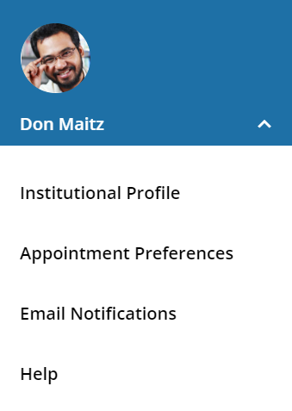
Your Profile
Click your name to open your Starfish Profile. Update your info for:
Institutional Profile: Contact information, photo, bio. (info students see).
Appointment Preferences: Appt. defaults, Locations, Calendar Managers.
Email Notifications: Appt. email (iCals) and tracking item email options.

Office Hours
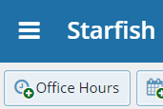
Select Office Hours to create single or recurring set of office hours.
Tips on completing the Add Office Hours form:
Title: Displays on your calendar to distinguish sets of office hours.
Where?: Options are added via Profile > Appointment Preferences tab.
Office Hour Type: If you are using a Kiosk, use Scheduled and Walk-ins.
Appointment Types: Use to limit an office hour block to one meeting type i.e. Advising.

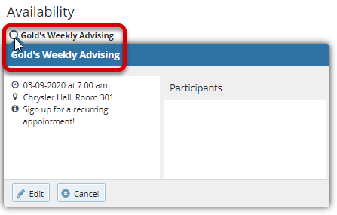
Edit/Cancel a series of office hours from the Agenda view. Hover over this icon to edit the frequency, time of day, locations, office hour types, minimum and maximum duration of appointments, appointment types, instructions, or start/end date of the series.
Important Note:
Once an office hour block is saved, you will not be able to edit weekdays on which it occurs or type of frequency (i.e. weekly).
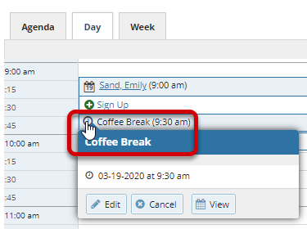
Edit/Cancel individual occurrences from the Day view of the calendar. Hover over this icon to display a pop up card from which you can take additional actions.

Progress Surveys
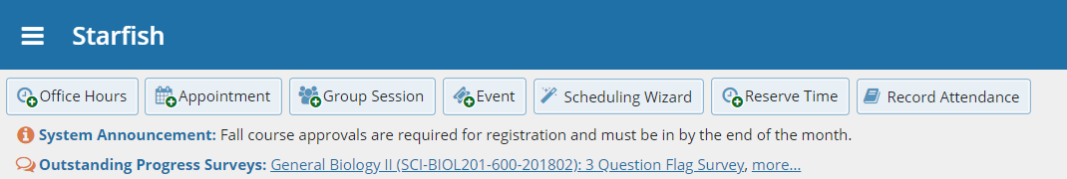
Select the Outstanding Progress Survey link on the Starfish Home page.
Check the boxes presented for each desired item/ student combination.
Click the comments icon () to add notes.
Click the information icon ()to verify whether the student can view the flag.

Important Note:
Don’t click Submit until you’re done! You cannot modify a submitted survey. Use Save Draft if you aren’t ready to submit your survey.

