

BIG BEND COMMUNITY COLLEGE
RESIDENCE HALLS HANDBOOK AND CONTRACT

PLEASE REVIEW THIS HANDBOOK THOROUGHLY

Welcome to the Big Bend Residence Halls. We are delighted that you have chosen to attend college. The experience of living on campus can be a wonderful experience, where life-long friendships are fostered along with self-discovery and vocational exploration. In the residence halls, you quickly learn your role in the community and then can translate it to the larger community of the world. Please take the time to get to know your neighbors, and to participate in community activities. The community is as good as you decide to make it!
You are responsible to adhere to the rules set forth in the Residence Halls Handbook and by virtue of being a student, you will be held accountable to follow the Big Bend Community College Student Code of Conduct. The Residence Halls Housing Contract, Residence Hall Handbook, and the provisions in BBCC Student Code of Conduct, are available for review and inspection electronically on the BBCC Residence Halls webpage or upon request from the Director of Residence Halls and Residential Life.
These documents become the Contract between you and BBCC with regards to the terms and conditions of occupancy. Changes in these documents may occur due to subsequent enactment of Washington State law or revised written notices applicable to the operation and administration of the Residence Halls.

YOU WILL BE HELD ACCOUNTABLE FOR ITS CONTENTS

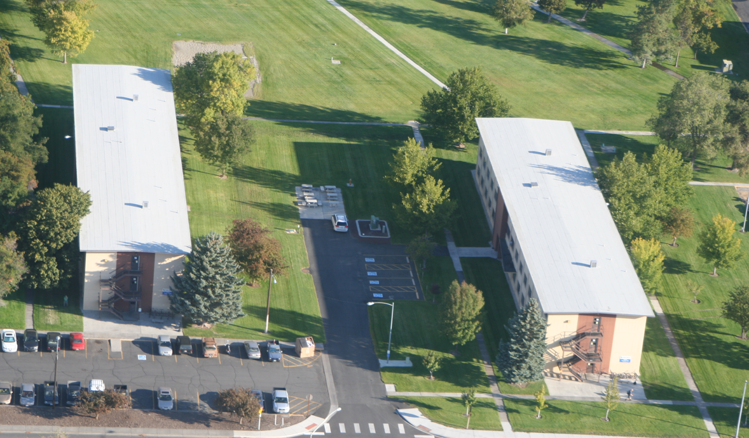

WELCOME
Welcome to the Big Bend Community College Residence Halls. Residence Hall living offers students the opportunity to encounter people with many different backgrounds. Accordingly, this sort of living requires a certain sensitivity to, and acceptance of, the rights of others. Most college students find that the positive experience of learning to live with other people, their habits and different culture, far outweigh the minor loss of privacy and autonomy they might otherwise enjoy. By practicing cooperation, compromise and courtesy in a group living situation, your resident living experience can prove to be a valuable addition to your academic experience.
On-campus housing at Big Bend Community College offers a cost-effective solution to your student housing needs. It provides convenient access to all college facilities, giving the student the opportunity to spend most of their time pursuing their academic and personal development goals.

STAFF
Staff support and resources are available to assist with any problems that may arise as you attend classes here at Big Bend Community College.
Director of Residence Halls & Residential Life (DRH)
Full time professional in charge of all the housing policies, facilities, and staff in the residence halls at Big Bend Community College.
HEAD RESIDENT ADVISOR (HRA)
Student staff assigned to help oversee RA interactions within the residential community.

Resident Advisor (RA)
Student staff assigned to each floor of a residence hall to establish community. Helps plan floor activities, mediate conflicts, regulate policies, answer questions, and generally promote academic success.
Residence Hall Custodian AND MAINTENANCE
Full time staff assigned to provide both cleaning and maintenance activities for the Residence Halls and the surrounding grounds.
RESIDENT HALL CUSTODIAN HELPER
Student staff assigned to help custodian ensure cleaning standards for the Residence Halls is maintained.

Residence Hall COMMUNITY STANDARDS COMMITTEE
A committee comprised of College staff approved by the DRH to provide recommendations of disciplinary procedures and sanctions for upholding Community Standards.

FACILITIES SUMMARY
Student residents are housed in two three-story buildings. Both Philips Hall (5000 building) and Viking Hall (6000 building) provide housing for students attending Big Bend Community College.
Cooking facilities are available on three floors: second floor of 6000 building, and first and third floor of 5000 building. Laundry facilities are available to residents free of charge and are located on the first floor of both buildings. Floor lounges are available for small group studying, program activities, and leisure socializing.
There are no on-campus housing facilities for married couples or families.
SINGLE ROOMS
We normally have a very limited number of single occupancy rooms available. These rooms are assigned on a seniority basis and carry a surcharge for single occupancy. All students can request to be placed on the list for single room occupancy.

RESIDENCE ROOMS
Rooms are furnished with two desks, two chairs, two single bed frames with twin extra-long mattress and metal closets with ample room and locking capability (resident provides their own padlock). Beds are adjustable and lend themselves to arranged in different configurations
OFFICES
The DRH Office is in Philips Hall (5000 bldg.) in room 5116. This office is where meetings are held, and official paperwork is submitted.
The Resident Advisor office is located on the first floor of Viking Hall (6000 bldg.) room 6119. Its purpose is to assist residents with lockouts, room repair requests, programming, recreational equipment, and video equipment checkout. Hours of operation are posted outside the office door.
BBCC Security occupies rooms 6116. This office is the home base security department. They are willing to assist students with various matters, and often patrol the campus throughout the day and night.

SERVICE INFORMATION

MAIL (7505 Chanute Street NE, Moses Lake WA 98837)
BBCC RESIDENCE HALL mail service is an extension of the U.S. Postal Service; therefore, it follows federal guidelines including prohibition of mail fraud, etc. Violations of U.S. postal regulations will be turned over to the U.S. Postal Service and will be subject to college disciplinary procedures.
Mail service and forwarding may be temporarily interrupted during breaks, summer vacation, or staff vacations.
Mail and packages will be held in the Resident Advisor office in room 6119. You can pick up your mail by showing and ID to claim your package or envelope.
WIFI is present in the residence halls for student academic use. It can also be logged into on the BBCC grounds.
Various recreational equipment is available for check out from the RA office. This includes volleyball nets, ping pong paddles, billiard sticks, cards, board games, and other items.
SAFETY AND HEALTH CONCERNS
OPIOIDS
Education and Awareness HB 2112: All Washington state public and private higher education institutions must provide opioid and fentanyl prevention education and awareness information to students. This education can be delivered in person or electronically and must include details about the "good Samaritan" statute. The education materials must be posted on each institution's public website for students, parents, and legal guardians to access. Naloxone and fentanyl strips must be made available to students on campus in various accessible locations such as student wellness centers, student union buildings, and student housing. Institutions must provide education and training on administering naloxone to staff working in residence halls
MENINGOCOCCAL MENINGITIS VACCINE
The Advisory Committee on Immunization Practices (ACIP) and Washington State Department of Health (DOH) Vaccine Advisory Committee recommend that all students entering college and living in congregate settings (including Residence Halls, fraternities and sororities), should receive the meningococcal vaccine. The Grant County Health District follows the general recommendations of the ACIP under advisement from the Washington State Department of Health Vaccine Advisory Committee.
College students, particularly those that live in Residence Halls, have a modestly increased risk of getting the disease Meningococcal meningitis, which is the leading cause of life-threatening meningitis in young adults in the U.S. The infection is spread by air droplets like the flu and has flu-like symptoms initially. The disease can easily be misdiagnosed as something less serious because symptoms are similar to the flu. The most common symptoms include high fever, headaches, neck stiffness, confusion, nausea, vomiting, lethargy and/or rashes. Anyone with similar symptoms should contact a physician immediately. Symptoms can progress rapidly and lead to shock or death in hours.
A regular meningococcal vaccine protects against four of the five most common types of the disease, which can result in serious or life-threatening illness. Vaccine protection lasts three to five years and can prevent 50-70% of cases on college campuses. Meningococcal disease usually peaks in late winter and early spring.
Those students who will be attending college and residing in congregate settings should talk with a health care professional about obtaining the meningococcal vaccine prior to college entry. Places in Moses Lake, WA to obtain the vaccination are Samaritan Healthcare, Confluence Health, and Moses Lake Community Health Center.
If you have any questions, feel free to contact your local health department or the Grant County Health Department.

REPORTING AND COMPLIANCE
THE CLERY ACT
The Jeanne Clery Disclosure of Campus Security Policy and Campus Crime Statistics Act (Clery Act) is a federal statute codified at 20 U.S.C. § 1092(f), with implementing regulations in the U.S. Code of Federal Regulations at 34 C.F.R. 668.46. The Violence Against Women Act of 2013 adds additional requirements under the Campus Sexual Violence Act (SaVE Act) provision, Section 304. The Clery Act requires all colleges and universities that participate in federal financial aid programs to keep and disclose information about crime on and near their respective campuses. Compliance is monitored by the United States Department of Education, which can impose civil penalties against institutions for each infraction and can suspend institutions from participating in federal student financial aid programs.
The law is named for Jeanne Clery, a 19-year-old Lehigh (Penn.) University freshman who was raped and murdered in her campus residence hall in 1986. The backlash against unreported crimes on numerous campuses across the country led to the Jeanne Clery Disclosure of Campus Security Policy and Campus Crime Statistics Act. The Clery Act, signed in 1990, was originally known as the Crime Awareness and Campus Security Act. All students are encouraged to report all crimes to Campus Safety. For more information on the Clery Act and BBCC’s annual Campus Security and Fire Report, visit www.bigbend.edu/safety.

ALCOHOL AND DRUGS POLICY (Including Marijuana)
Possessing, delivering, sharing, transporting, administering, consuming, selling, or knowingly being in the presence of any alcoholic beverage, illegal drug, or controlled substance on the Big Bend Community College campus is prohibited.
The possession or use of paraphernalia and/or compounds which produce hallucinations or illusions when introduced into the body and all compounds covered under federal and state drug control laws is prohibited, except when the use or possession of a drug is specifically prescribed as medication by an authorized practitioner. However, on-site use, medical use, or possession of marijuana is prohibited (by Federal Law).
Detectable intoxication within the BBCC Residence Halls is prohibited.
CIVIL RIGHTS NON-DISCRIMINATION TITLE IX
Big Bend Community College complies with all federal and state rules and regulations and does not discriminate on the basis of race, color, religion, national origin, age, status as an honorably discharged veteran or military status, sex, sexual orientation, marital status, genetic information, pregnancy, the presence of any sensory, mental, or physical disability, or the use of a trained guide dog or service animal by a person with a disability. Inquiries regarding compliance and/or grievance procedures may be directed to the college’s Title IX/ Officer and/or Section 504/ADA coordinator through the Vice President of Human Resources & Labor, 7662 Chanute St. NE, Moses Lake, WA 98837, 509.793.2010.
SEXUAL ASSAULT
Sexual assault includes sexual contact with another person without, or that exceeds, that person's consent.

Consent cannot be obtained when force or threat is used to gain consent. Consent cannot be obtained where the respondent knew or reasonably should have known that the other person was incapacitated; or

Consent cannot be given or granted by a person who is under the statutory age of consent in accordance with the criminal code of Washington, chapter 9A.44 RCW, Sex offenses.

A respondent's use of alcohol or drugs is not a valid defense to a charge of sexual assault, and a respondent will be held to the standard of a reasonable sober person in evaluating whether the respondent knew or reasonably should have known that the complainant was incapacitated.

Violations of this law and College policy can be handled in various ways, therefore it is important to report the incident to a College official as soon as possible. Temporary arrangements might need to made until the College or law enforcement agency has conducted their investigation.

MISSING RESIDENT HALL STUDENT POLICY AND NOTIFICATION PROCEDURES
If a student living in BBCC on-campus student housing is determined to be missing, the College will initiate notification procedures. There is no time period that will delay this notification procedure.
For purposes of this policy, a student may be considered to be a “missing person” if the person’s absence is contrary to his/her usual pattern of behavior and/or unusual circumstances may have caused the absence. Such circumstances could include, but not be limited to a report or suspicion of foul play, suicidal thoughts, concerns about drug or alcohol use, is involved a life-threatening situation, or has been in association with persons who may endanger the student’s welfare.
Residence Hall staff advises every student who lives in on-campus student housing, regardless of age, that he or she may register one or more individuals to be a confidential contact strictly for missing persons purposes. The contact person can be anyone. Students are given this option even if they have already identified a general emergency contact. A student may identify the same individual for both purposes, but BBCC will not assume that a general emergency contact is also the missing person contact. Students are offered this option annually during the housing application process, regardless of whether they chose to register a contact the previous year. If any students move into on-campus student housing mid-year, Residence Hall staff gives them the option to name a contact person as well. Information on how to register a contact or contacts is available by reaching out to the Director of Residence Halls.
Reporting a Missing Residence Hall Student
If a member of the College community has reason to believe that a student who resides in on-campus housing is missing, he or she should immediately notify the Big Bend Community College Campus Safety at 509.793.2286. Campus Safety will generate a missing person report and initiate an investigation as well as notify the Grant County Sheriff’s Office.
If a student has been missing for 24 hours, and the student is under age 18 and not emancipated, BBCC will notify the student’s custodial parent or guardian and the student’s emergency contact if he or she has registered one.
ROOM ENTRY POLICY
Authorized personnel (campus security, facility operations staff, housing staff, and college management) may enter any room for the purpose of routine inspection, repairs, maintenance, cleaning, to emergency response, or any other official business, for reasons of health and safety, and when authorized personnel have reasonable grounds for believing established rules, policies, and community standards are being violated, even in the absence of the occupant. Examples of community standards include, but are not limited to, noise, odor, alcohol, and drug complaints. Staff may enter a resident’s room if the resident is not present to eliminate disruptive noise (examples: beeping alarm clocks, smoke detectors) which may violate an individual’s right to sleep or study.
INTERRUPTIONS OF SERVICE
BBCC is not responsible for the continuation of mail, custodial, heating, maintenance, or security service at normal levels in the event of a natural disaster, strike, or lockout of public employees or supplier’s employees, power-water-sewer interruptions from on-campus or off-campus sources, or in the event of other causal events beyond the control or reasonable anticipation of college housing.
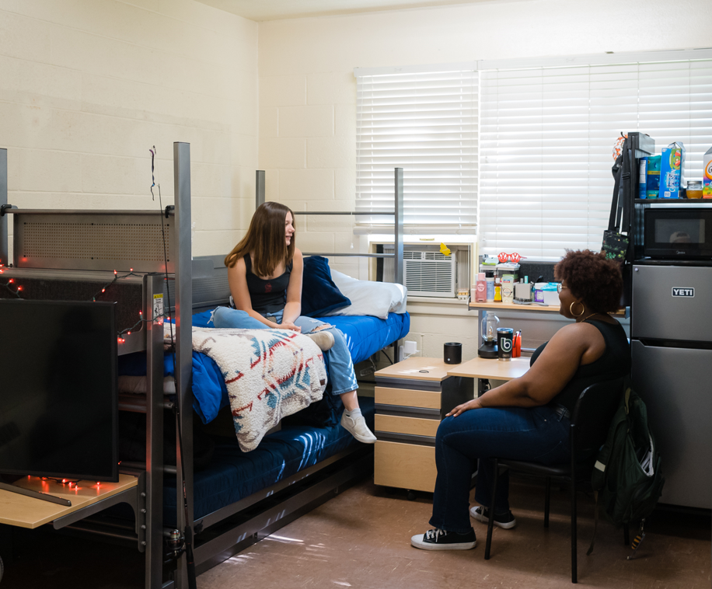

FIRE SAFETY & EVACUATION PROCEDURE
Fire drills will be held periodically to ensure that residents are aware of the alarm and the emergency building evacuation plan. The building evacuation plan is posted on every floor and should be reviewed by each person. Every alarm must be treated as an emergency and all persons must evacuate the building immediately.
WHAT TO DO
- If you discover or suspect a fire, pull a fire alarm, and leave the building by the closest, safe exit.
- Feel the door with the back of your hand to ensure that it is not hot before opening it. If it is hot, do not open it. If it is not hot, open the door carefully. If smoke or heat is present, close the door and stay in the room. Seal the cracks around the door with whatever is available (a wet towel, etc.). Call “911” and report that you are trapped. Be sure to give them your room number, address, and location. If your phone doesn’t work, hang a sheet, jacket, etc. out of the window to attract attention.
- If the hall is free of smoke or heat, close your door and exit immediately by the closest stairwell. If the nearest exit is blocked, go to another exit.
- If all exits are blocked, go back to your room. Close the door, hang something out of your window and signal for help.
- Move quickly in a crouched position when escaping through a smoke-filled corridor. Place a wet cloth over your face and head.
- Once outside the building, move away from the building about 1.5 times the building height, avoid standing beneath overhead electrical lines, and watch for vehicle traffic. When you reach the evacuation location, contact a staff member, and give him/her as much information as possible.
- Do not reenter the building until you have been given the OK by police, fire officials or residence hall staff. THE SILENCING OF THE ALARM DOES NOT INDICATE THE BUILDING IS SAFE TO REENTER! Never re-enter a burning building to save your personal possessions.
Evacuation Locations
Whenever the building must be evacuated (bomb threat, fire alarm), residents should be directed to the following location:
- If safe, Philips Hall (5000 bldg.) and Viking Hall (6000 bldg.) residents assemble on the north side of 6000 building. Stay away from vehicle traffic.
Mobility and hearing-impaired students
- Please notify fire/police/BBCC maintenance or security of the location of permanent or temporary mobility or hearing-impaired students. In case of fire, Grant County Fire District 5 will prioritize your location for rescue considerations. The Residence Hall staff will assist persons with a disability in developing an evacuation plan.
Phone Numbers
- Emergency: 911
BBCC Campus Security: 509.793.2286
DEFINITIONS & PROCESSES
For the purpose of this Handbook and Contract the following definitions shall apply:
BREAK: The time-period between each term when classes are not in session.
DAMAGE/SECURITY DEPOSIT: A deposit of a sum of money held in a student’s account, which is paid in relation to fees (damage, lost keys, lockouts, cleaning, late fees, etc.), or unpaid housing fee which ensures that both the items and room are returned and in good condition.
FINALS WEEK: Period starting the last day of classes until the last day of final exams.
RESIDENCE HALLS OFFICE: Administrative responsibility of BBCC Residence Hall applications, contracts, check-in, room transfers, checkout, lockouts, room repair requests, and mail distribution. Hours of operation are posted on office door.
PREPAYMENT: An installment of room charges for the academic quarter prior to check-in.
RESIDENCE HALL: Includes Big Bend Community College Residence Office, Residence Halls, surrounding sidewalks, and parking lots.
ROOM TRANSFER: A room change approved by the Residence Halls Office.
- ELIGIBILITY FOR HOUSING
- To be eligible for BBCC housing, you must be enrolled in at least ten (10) official college credits during the entire time of occupancy, with the exception of instructional breaks (winter break, spring break, and summer breaks if enrolled each subsequent quarter). The ten (10) college credits must be from BBCC courses.
- The DRH must approve, in writing, any exceptions to the ten (10) credit requirement for summer quarter enrollment when required by an academic program or for a resident in their final quarter when needed to complete their degree.
- You may be asked periodically to provide proof of current enrollment.
- Residents who fall under 10 credits (regardless of the point in the quarter) due to withdrawal, suspension, expulsion, or other means may be given no more than 24 hours to vacate the Residence Halls.
- Residents must be in good academic standing (minimum 2.0 cumulative GPA).
- Residents not in good academic standing may be given no more than 24 hours to vacate the Residence Halls.
- Submission of this Contract document does not guarantee that you will be assigned a room in the BBCC residence hall.
- Prospective resident applications will be reviewed after the entire application and $300 security/damage deposit are received.
- Students who have a history of conduct that is not conducive to group living and a positive learning environment or have had a delinquent account or history of financial delinquencies for housing related charges may be denied admission to the BBCC Residence Hall.
- A qualified student for whom space is not available will be placed on a waiting list and notified of their status.
- Registered Sex Offenders (Levels I, II, III) are not eligible to live in the BBCC Residence Hall.
- BBCC is committed to a policy of nondiscrimination in all its operations and facilities. Assignments to residence halls are not based upon race, color, religion, sex (including transgender status, sexual orientation and pregnancy), national origin, age, disability or genetic information.
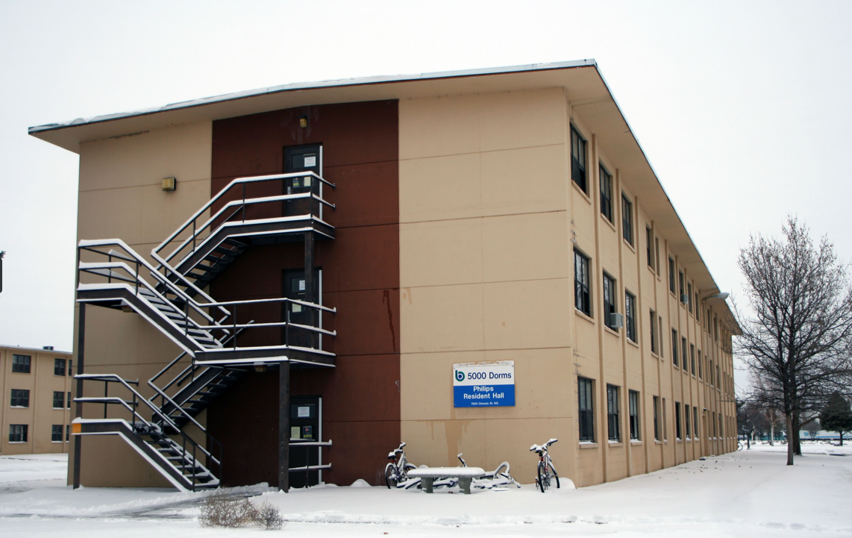

- HOUSING ASSIGNMENT PROCESSES
ROOM ASSIGNMENTS
The Residence Halls reserves the right to assign a person to any vacancy at any time
Quarterly Room Assignments
Room assignments for the quarter are made based on the date of the application, responses given on the application, housing Contract, and the date the $300 deposit was received.
While we make every effort to do so, the Residence Halls Office cannot guarantee we will be able to meet all requests or guarantee room preference or compatible roommates.
Behavior that deviates from information provided in the application may be grounds for relocation within the BBCC RESIDENCE HALL to a community that better suits the residents’ lifestyle.
Roommate requests may be accommodated based on space availability.
Both residents are of the same gender AND request each other as roommates.
ADMINISTRATIVE ROOM ASSIGNMENTS
The Residence Hall Office reserves the right to make or change room assignments at any time based on administrative needs. This includes, but is not limited to, consolidation of space and/or sanctions as a result of conduct or Contract violations.
TEMPORARY ASSIGNMENTS
The DRH and approved staff reserve the right to establish temporary room assignments as needed.
Applicants may be assigned a temporary room until their permanent room is available.
When the permanent room becomes available, residents agree to complete the room transfer within 48 hours of notification.
UNAUTHORIZED ROOM CHANGES
Any living arrangements not approved by the DRH are strictly prohibited.
This includes but is not limited to residents sharing or exchanging keys and/or living space.
All room assignment changes must be approved by the DRH.
Unauthorized room and/or living arrangements are subject to a Major Infraction fine of $150 and may result in eviction from the Residence Halls.
ROOMMATE VACANCIES
If a roommate fails to occupy the room or moves out:
Residence Halls staff are responsible for finding another roommate. Residents and rooms will be consolidated as needed and based on availability.
If Residence Halls staff are unable to find a roommate, opportunity for the resident to obtain a single room for the remainder of the quarter is a possibility. This option is on a space availability basis.
If, after paying for a single-room, another roommate is assigned to the room, the prorated balance of the single-room charge will be refunded.
In the event that a resident has requested but a roommate cannot be found to fill the vacancy of a shared-room, the single resident will not be charged the single-room rate.
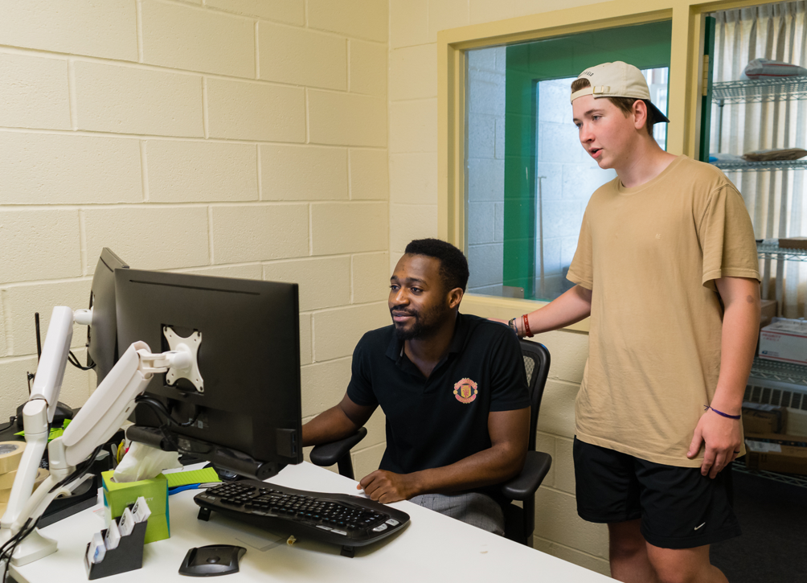
- TERMS OF CONTRACT
This Contract begins when a resident completes the check-in process and ends when the residence completes the checkout procedures. The Contract is for the academic year while the student is enrolled at Big Bend Community College.
In general, BBCC will establish check-in and check-out dates that correspond to the beginning and end of each academic quarter. These dates and times will be communicated to residents prior to the first day of classes. Rental rates are charged on a per quarter basis and correspond to these college established check-in and checkout dates.
CHECK-IN
Check-in is complete when a student executes this Contract and registers with staff upon their initial occupancy.
As part of the check-in process, each resident will complete with their RA the room condition check-in form, via laptop, and will receive room key, perimeter door key FOB, and other important information. All new and returning residents will attend mandatory orientation within days of check-in.
All contents of the room, including floors, ceiling, windows, doors and furniture are considered room inventory items.
As a resident of the room, you are responsible for the inventory and the room in its entirety while you have room keys, you occupy the room.
Care should be given to ensure a complete and accurate inventory, as you will be held responsible during checkout for any damages not listed on the sheet.
Any student that moves into Big Bend Community College Residence Halls agrees to take responsibility for all items listed on the computer form.
Items that you feel do not belong in the room during your inventory should be reported immediately to the Residence Halls Office.
CHECK-OUT
Check-out is complete after the academic year, or a resident notifies the Residence Halls Office of their intent to vacate 30 days in advance or discusses the circumstances in which they need to leave.
Residents must adhere to the BBCC RESIDENCE HALLs checkout procedures when checking out by completing the Check-Out Room Condition form with their RA. To avoid additional charges when checking out, whether vacating the BBCC Residence Halls or simply transferring to another room, residents agree to do the following:
- Notify the Residence Halls Office and staff at least 24 hours prior to checking out of BBCC residence hall.
- Remove personal belongings and clean the residence hall room.
- Schedule a meeting time with an RA to review the room and return all BBCC equipment, residence hall key and FOB to the Residence Halls Office.
EARLY ARRIVAL AND LATE DEPARTURE
If an applicant wishes to check-in prior to the beginning of an academic quarter, they must seek approval from the DRH & Residential Life in advance.
A daily-prorated amount will be charged each day prior to the quarter that you reside in the residence hall.
If an applicant wishes to checkout after the ending of an academic quarter, they must seek approval from the DRH & Residential Life in advance.
If approved, a daily-prorated amount will be charged for the days you stay after the academic quarter ends.
BREAKS
Pro-rated daily rates may be applied for residents occupying a room during breaks.

Resident will pay the pro-rated amounts if remaining in the Residence Halls during breaks (between Fall and Winter, between Spring and Summer, and/or between Summer and Fall).
Residents must adhere to all conditions in the Residence Hall Contract, Student Code of Conduct, and established Community Standards during breaks.
ROOM RATES, PAYMENTS & FEES
Please note that the Residence Halls Office cannot directly accept payments. All payments must go through the Business Office.
QUARTERLY ROOM RATES
Charges will vary by prorated early check-in and late check-out dates
Residence Halls Room Rates
 | Shared Room  (per person) | Single Room
Quarterly Rate | $1,230.00 | $1,765.00

PAYMENT SUBMISSION OPTIONS
Payments in-person can be made with cash, check, money order, credit or debit card at the Business Office located in the 1400 Building.
Checks and money orders must be made payable to Big Bend Community College. Payments must be paid in advance of due dates.
Payment by phone can be made by calling the Business Office: 509.793.2018
Payment by mail can be made with check or money order to:
Big Bend Community College
Attention: Business Office
7662 Chanute St NE
Moses Lake WA 98837
Payments can be made in FULL or by enrolling in the Residence Halls Payment Plan.
DEADLINES
Upon receipt of your Residence Halls Housing Application and Deposit, the Business Office with the approval of the Residence Hall Office will post quarterly room charges to the student’s account.
The Residence Halls does NOT post monthly charges.
Residents will pay any prorated amount during early check-in and late checkout depending on move-in and move-out dates.
Due date will be posted at the bottom of the prorated housing bill.
Late Fees
A $5.00 per day fee will be added to the student’s account and after. . .
One (1) Week Late: Business Office will add the late fees to student’s account if resident hasn’t paid in FULL or joined the Residence Hall Payment Plan.
Two (2) Weeks Late: Business Office adds late fees and Director of Residence Hall is notified. DRH provides notice to resident of late payment and gives an eviction date if payment is not made (Eviction Date will be one week from the day of the notice).
Three (3) Weeks Late: Business Office adds late fees and notifies DRH to initiate eviction.
DRH will give an eviction notice to resident and notify the Business Office to begin the collection process.
Resident will have 24 hours to remove all belongings from the BBCC Residence Halls and forfeits the $300.00 deposit.
Residence Halls Payment Plan
Requires a $15.00 non-refundable enrollment fee and option to pay housing bill in three equal parts. The first payment is due the first day of instruction for the quarter.
The remaining two payments will be due on the same day of the subsequent two months.
EXAMPLE: September 19, October 19, November 19
If the due date(s) land on a weekend, payments will be due the Monday after the due date.
FINANCIAL AID PAYMENTS
The amounts and disbursement date(s) of financial aid funds will vary for each student resident. Financial aid awards are posted to the student’s account.
Charges for housing are placed on the student account for the entire quarter. Generally, financial aid is applied toward tuition and fees first and then other departments and fees within the college.
Residents are responsible for all remaining balances by the specified due date.
Financial Aid payments are not removed, adjusted, or refunded by BBCC Residence Halls or Business Office staff.
Financial aid may only be applied to the corresponding quarter in which the resident resides at the BBCC Residence Halls.

BILLING RIGHTS
BILLING REVIEW: In case of errors or questions, a debtor may challenge a charge within 30 days after the first bill on which the suspected error or problem appeared by directing his or her inquiry to the office initiating the charge.
If an error has occurred, charges will be adjusted. Residents have the right to appeal charges made to their account.
DISPUTES: Billing disputes must be filed, in writing, with the DRH. Disputes are first heard by the DRH and then, if further appeal is desired, by the Vice President for Finance & Administration. Decisions by the Vice President for Finance & Administration are final.
- COMMUNITY STANDARDS
The Community Standards are a set of rules and expectations which promote a positive learning and living community that all students, residents, and guests will be expected to follow. The standards work in conjunction with BBCC policies.

Community Standards do not preclude enforcement of the Big Bend Community College Student Code of Conduct, any other college policies, state, or federal laws.
Every Community Standard is subject to an infraction fine or sanction.
CIVILITY
  - Residents are expected to maintain integrity in all relationships, respect the dignity, and exhibit respect for individual difference in culture and lifestyles.
  - Residents will at no time physically, verbally, mentally, psychologically, or sexually abuse or assault any member of this community (including BBCC Residence Hall staff), nor participate in or condone any form of bigotry, harassment, intimidation or threat, whether verbal, written, physical or psychological, direct or implied.
    - Violations may result in an immediate temporary suspension of housing of up to a seven (7) day or an immediate eviction from the BBCC Residence Halls.
    - Any suspension or eviction will also include being trespassed from the BBCC Residence Halls.
    - A Major Infraction fine of $150 may be charged to the student’s account and the Residence Halls Contract may be immediately terminated.
ALCOHOL AND DRUGS (Including Marijuana)
2.1. Possessing, delivering, sharing, transporting, administering, consuming, selling, manufacturing, or knowingly being in the presence of any alcoholic beverage, illegal drug, or controlled substance is prohibited.
2.2. The illegal possession or use of paraphernalia and/or compounds which produce hallucinations or illusions when introduced into the body and all compounds covered under federal and state drug control laws is prohibited, except when the use or possession of a drug is specifically prescribed as medication by an authorized practitioner.
2.3 On-site use, medical use or possession of marijuana is prohibited (Federal Law).
2.4 Detectable intoxication within the BBCC Residence Halls is prohibited.
2.5 Residents may not display alcohol or drug paraphernalia. Paraphernalia will be confiscated and destroyed. This include: bottles, cans, packaging, posters, funnel, tubing, etc.
2.6 Rapid-consumption device or “beer bong” is prohibited.
2.7 Alcohol containers, such as beer cans, wine bottles, liquor bottles, or packaging.
2.8 Pipes designed for the use of illegal drug consumption
2.9 Hypodermic needles and related equipment designed for the use of illegal drug consumption
2.10 Residents are responsible for their own actions and the actions of others who are in the facility. Residents must immediately report all violations to the DRH. Withholding knowledge of suspected alcohol and drug misconduct is prohibited.
All items 2.1 through 2.10 are classified as a MAJOR INFRACTION
A fine of $150 will be charged to the student’s account and the Residence Halls Contract may be immediately terminated.
PETS
3.1 Pets are strictly prohibited in the BBCC Residence Halls.
3.2 Unauthorized pets are a major infraction of $150 fine and may lead to eviction
EMOTIAL SUPPORT ANIMALS (ESA)
Information on ESAs available from the DRH or Accommodation & Accessibility Services Coordinator.
Applications for an ESA in the Residence Halls must be approved by the DRH before they can enter the building.
4.1 Unauthorized ESAs will be treated as Pets as outlined in section 3.1, & 3.2, subject to a $150 fine, and may lead to eviction
COMPLIANCE WITH COLLEGE OFFICIALS
5.1 Residents must comply with and respond as instructed to the reasonable and lawful requests of any BBCC residence hall or college official acting in the performance of his/her duties, including presenting proper identification and meeting with, or contacting, BBCC residence hall or college official upon request.
DISRUPTIVE NOISE
6.1 Courtesy hours are when any resident’s behavior to self or other residents that disrupts the community or demonstrates an unwillingness to live in a group setting is prohibited.
- Examples of disruptive noise (include but are not limited to): not keeping volume on devices low enough to not hear it in the neighboring rooms or more than three doors down in the hallway; yelling, screaming, bouncing of sports balls inside of the building or within 50 feet of any opening to the building.
- Another example is knocking on doors loudly and leaving. Or talking in the hallway once quiet hours have begun.
- If anyone from a neighboring room complains then you are being too loud and you should reduce the noise immediately.
6.2 Philips and Viking Hall quiet hours are Monday through Sunday, 10:00 p.m. to 8:00 a.m. Beginning the start of each final’s week through the end of finals week, quiet hours will be 24 hours a day in both Philips and Viking Halls.
ROOM & HALL CARE
  - Residents agree to uphold reasonable care of their room and its furnishings, and to maintain sanitary and safe conditions acceptable to BBCC Residence Halls. To prevent custodial charges, residents are responsible for the removal of their own trash to a centralized trash collection area (dumpster).
  - Trash placed in bathrooms, laundry rooms, hallways, etc. is prohibited and is subject to a $50 cleaning charge per violation.
  - Removal of any bed, desk or other furnishings is prohibited, and subject to cost of the replacement.
  - Personal beds and waterbeds are prohibited.
  - All furniture must be kept in the room to which it is assigned.
  - Residents are responsible to restore the room to its original condition and configuration prior to checkout. This requires that all components, equipment and furnishings, are in the room and assembled.
  - Residents are financially responsible for any damage, loss, or uncleanliness to their room and furnishings other than normal wear and tear.
  - Any costs to return the room to its original condition will be charged to the resident.
  - Residents agree to pay for any damages to the BBCC Residence Hall willfully or negligently caused by the resident or the resident’s guests.
  - Residents are responsible for paying for damages to the building and for damaged or missing furniture, equipment, and room contents.
  - Residents are collectively responsible for any damages that occur within common areas. If damage in common areas within a hall cannot be traced to a specific individual or group but was in substantial part caused by individuals, groups or guests acting from within the BBCC residence hall the residents of that hall may be charged collectively.
  - Residents are not permitted to contract for painting, repairs, or lighting/electrical changes; BBCC residence hall office will facilitate all repairs/changes. Residents are required to notify the Residence Halls Office immediately of any needed repair to their room, bathroom or common areas.
SMOKING
8.1 All Residence Halls are designated as non-smoking facilities. Smoking on BBCC property is only permitted in designated smoking areas and twenty-five feet away from the buildings.
8.2 Resident will be charged for all cleaning and decontamination costs incurred from smoking in the Residence Halls by the resident or their guests.
STORAGE
9. The BBCC Residence Halls do not provide storage.
FIRE SAFETY
Fire drills will be held periodically to ensure that residents are aware of the alarm and the emergency building evacuation plan. The building evacuation plan is posted on every floor and should be reviewed by each person.
10.1 Every alarm must be treated as an emergency and all persons must evacuate the building immediately.
10.2 Possession, displaying or burning of flammable materials including, but not limited to, fireworks, candles, incense, gasoline, and kerosene lamps is hazardous to the health and safety of residents and is prohibited inside the BBCC Residence Halls. Barbecues must be conducted at a minimum, at least twenty-five feet away from buildings.
10.3 No fuel-powered motor vehicles or associated parts are permitted within the BBCC Residence Halls for use, maintenance, repair, or storage.
10.4 All appliances or electrical devices are required to be compatible with 110 volts 60 cycle voltage and UL approved. Refrigerators should be less than four cubic ft.
10.5 Multi-plug adapters and the “piggy-backing” (plugging one power strip into another power strip) of power strips are prohibited.
10.6 All kitchen appliances should be attended while cooking and turned off when finished.
10.7 Surge protected multi-plug adapters/power strips are allowed.
10.7.1 When adapter/power strips are used, circuit breakers and/or reset buttons are required.
10.8 Old Space heaters are prohibited. Heaters that are tip-over protected, and automatic shut off thermostats may be approved only during the winter months.
10.9 Hot plates and any other ground or countertop heating devices are prohibited.
10.10 Decorative lighting (string lights) cannot be plugged into each other.
10.10.1 Only one (1) set of decorative lights shall be plugged into one approved circuited power strip or wall socket.
10.11 Halogen lamps, lava lamps and disco lamps are prohibited.
10.12 Ceiling lights, lamps of any type, and air conditioning/heating units cannot be covered.
10.13 A Major Infraction of $150 and immediate Contract termination may be imposed for any of the following:
10.13.1 failure to evacuate,
10.13.2 activating false alarms in BBCC residence hall,
10.13.3 creating a fire hazard,
10.13.4 malicious burning, or
10.13.5 tampering with fire equipment (fire extinguishers, plastic ties securing valves, fire alarm pull stations, smoke detectors fire hose connections, sprinkler heads, sprinkler pipes, hoses, connections, valves, emergency exit signs, etc.).
10.14 Fire and life safety inspections will be conducted periodically for fire or health hazards. Additionally, periodic inspections can also occur depending if BBCC Residence Hall staff has been notified of a health and/or safety concern.
10.14.1 A $50 fine per violation can be imposed for not abiding by the received citation or verbal instructions of the inspector or college staff regarding the correction of fire or health hazards and violations.
10.14.2 Residents must resolve fire or health hazard issues in a timely manner, as indicated by BBCC Residence Hall staff.
10.15 Fire Aisles and Exits: Grant County Fire District 5 requires that all exit aisles, hallways, and stairs be kept clear of any obstruction. Items left in these areas will be subject to impound.
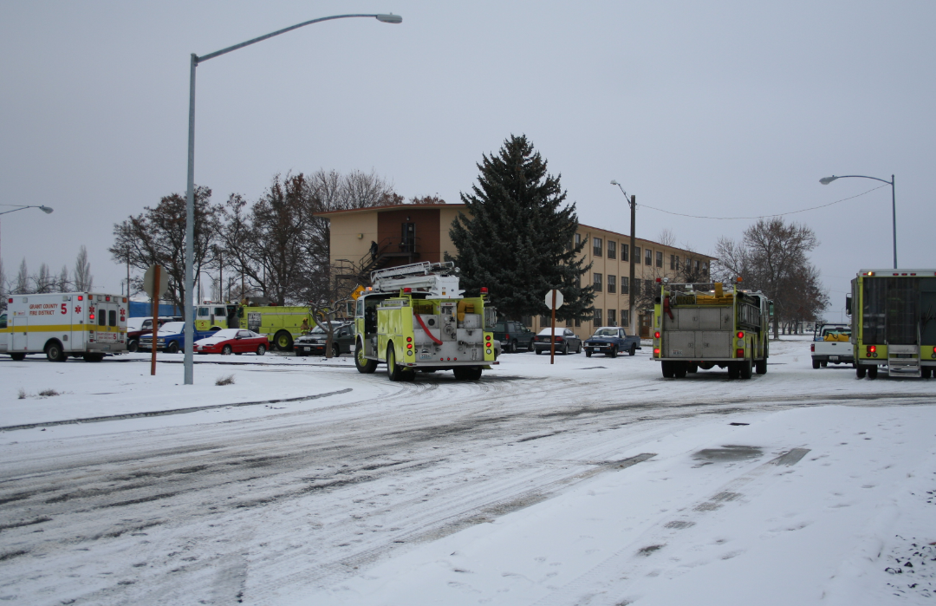

SECURITY
Security is a shared responsibility between residents, the college and college staff members. Residents are encouraged to take all reasonable steps to ensure their personal safety and security. Residence Halls staff works with Campus Security and residents to identify and resolve security problems. Crime prevention strategies are learned behaviors. We urge residents to practice safer behaviors as soon as they move in.
11. Residents who jeopardize the safety or security of other residents by propping open or disabling exterior doors or letting unauthorized individuals into the building (intentionally or carelessly) may face disciplinary action.
Residents are expected to:
11.1 Lock room doors at night, when asleep, or whenever out of the room
11.2 Refrain from propping open building doors
11.3 Refrain from allowing strangers into BBCC Residence Hall
11.4 Report suspicious activity or people
11.5 Report crimes immediately
11.6 Report lost keys immediately so room lock changes can be made if necessary
11.7 Take appropriate steps to secure personal property such as bikes, cars, jewelry, cash, or electronic equipment
11.8 Remove opportunities for crime by being informed, alert, and conscientious community members
COMMERICAL SOLICITATION, ADVERTISING, AND PROMOTION
Commercial solicitation, advertising, promotion, and commercial transactions are prohibited in all areas of the BBCC residence hall. Solicitation is defined as:
12.1 The sale of services or products, or the seeking of funds, signatures, merchandise or supplies.
12.2 Attempts to urge, incite, request, or advise a person or persons to adopt an idea, political solicitation, or purchase merchandise or services for personal profit or organizational gain.
12.3 Receiving business offers, goods, or services in the residence halls for business purposes of any nature.
12.4 Individuals or organizations seeking an exemption to this policy must contact the DRH & Residential Life for approval in advance.
12.5 BBCC Residence Hall staff do not guarantee 24/7 security services.
DANGEROUS DEVICES
14.1 Possession, carrying, or discharge of any firearm, dagger, sword, knife or other cutting or stabbing instrument, club, explosive device or any other weapon apparently capable of producing bodily harm (including shot guns, pistols, air guns, pellet guns, and paint-ball guns), whether loaded or unloaded, is prohibited on Big Bend Community College owned or controlled property except as expressly authorized by law or college policies is prohibited.
14.2 Misuse of personal protection spray devices (pepper spray for example) is prohibited. The owner is responsible and accountable for any misuse of these devices.

14.3 Per WAC 132R-117, the VP of Learning & Student Success has granted permission for residents of the Residence Halls to use utensils in the preparation of food for consumption.

EQUIPMENT USE
15.1 The use of any sports equipment, such as bicycles, scooters, skates, skateboards, balls, or Frisbees is prohibited within the BBCC residence hall buildings including hallways, lobbies, stairs, public areas, and posted areas.
15.2 BBCC Residence Halls equipment, supplies, and furnishings must not be dismantled or removed from their designated area.
15.3 Displaying lewd, indecent, or obscene material such as pornographic images or video on electronic devices in the BBCC residence hall is prohibited.
15.4 Charges will be assessed for misuse, removal, damage, or theft.
THEFT
16. Theft or conversion of college property or private property is prohibited.
KEYS
17.1 All Residence Halls keys and FOBs remain the property of the College and may not be duplicated.
17.2 Residents are not allowed to loan, sell, borrow, exchange, or transfer a Residence Hall key or FOB.
17.3 All assigned keys and FOBs must be returned at termination of residence.
17.3.1 A $150 fee per key will be assessed to the resident’s account or withheld from security/damage deposit.
17.3.2 A $50 fee per FOB will be assessed to the resident’s account or withheld from security/damage deposit.
17.4 Any violation of this key policy constitutes misuse of college property and constitutes a Major Infraction that may result in eviction from the Residence Halls.

LOST & FOUND ITEMS
Lost and found items of high value or importance (i.e. keys, wallets, backpacks, jewelry, electronic devices, etc.) will be sent to the Business Office in the 1400 building at the end of each business day.
All clothing items such coats, footwear and undergarments will be collected from in the Residence Hall laundry room, located on the first floor of each building. These items will be discarded every first (1st) and fifteenth (15th) of the month.
Removal of lost and found items by someone other than the owner or authorized by such constitutes theft of personal property.
LIABILITY
It is the residents’ responsibility to keep their rooms locked at all times.
BBCC is not liable for loss or damage to personal property in resident rooms, public areas, laundry rooms or storage rooms.

VISTORS & GUESTS
Visitor/Guest privileges are available during the academic term.

Please call 509-361-3647 to register your guest / visitors.

UNAUTHORIZED VISITOR/GUEST FINES
18.1 Any resident found to have an unauthorized visitor or guest will be subject to:
- First Offense: Minor Infraction, $50 fine and at risk of addition sanctioning.
- Second Offense: Major Infraction, $150 fine, and at risk of additional sanctioning up to and including to eviction

18.2 Residents are responsible and accountable for the conduct of their guests while on BBCC residence hall property or immediately adjacent areas, or at BBCC residence hall-sponsored or supervised activities. It is the responsibility of each resident host to see that their guests abide by the community standards and the BBCC code of conduct while in the BBCC Residence Hall. Violation of the community standards or violation of the Student Code of Conduct by the guest may be cause for immediate removal, the guest may no longer be allowed to visit the BBCC Residence Hall and the resident may lose privileges as well.

18.3 Guests are welcome in the lounge and residents’ rooms between the hours of 8:00 a.m. and 8:00 p.m. with accompanied resident. All guests must leave the facility at the end of established visitation hours.

18.4 Residents wishing to accommodate overnight guests may do so, provided they have the permission of their roommate and have checked guests in with the BBCC Residence Hall staff by 8:00 p.m.

18.5 There is a limit of two guests per resident.
18.6 Any single guest is not permitted to stay more than two consecutive nights.

18.7 Guest stays are not to exceed more than four nights per month.

18.8 Guests must respect quiet hours in the Philips and Viking Hall and that is between 10:00pm – 8:00am Monday-Sunday. Guests who are not following the Quiet Hours rule will be removed immediately from the Residence Halls.

  - Guests must be accompanied by a resident at all times in BBCC residence hall areas which include but are not limited to Residence Hall rooms, lounge, laundry rooms, and kitchens. Exceptions include when the host or resident is in the restroom. Guests must be escorted to and from resident rooms by their host. The DRH must preapprove any exceptions.

  - Guest privileges will be limited during BBCC’s finals week, scheduled breaks, holidays, or other days as decided by BBCC residence hall management.

18.11 The cost of repairing any damage to college property caused by guests of a resident will be charged to the resident.

18.12 The Residence Halls Office reserves the right to deny access to any guest whose behavior is deemed inappropriate or disruptive. Inappropriate or disruptive behavior towards BBCC Residence Hall staff, residents, or any other member of this community, is grounds for permanent guest expulsion.
18.13 Residents may not host anyone who is known to be persona non grata, defined as someone unwelcome or unapproved to be in the BBCC Residence Hall.

18.14 The presence of any such person constitutes a trespass.

18.15 Those trespassing on the premises of the college BBCC Residence Halls may be arrested under the ordinances of Grant County.

18.16 Minors (guests under 18 years of age) are not permitted in the BBCC Residence Halls unless authorized by the guests’/minor’s parent or legal guardian.

18.16.1 Residents may obtain a parent permission form for guests who are minors from the Residence Hall Office
18.16.2 Requires a parent/legal guardian signature and a copy of parental photo identification.
18.16.3 Children (13 years of age and under) visiting the Residence Halls must be accompanied by a parent or legal guardian.
18.16.4 Babysitting in the Residence Halls is strictly prohibited.

18.17 Residents may not sublease their room under any condition.

DISCIPLINARY PROCEDURES AND SANCTIONS
Disciplinary sanctions, including the immediate termination of the Residence Halls Contract as described therein, may be imposed against any resident found responsible for committing, attempting to commit, or intentionally assisting in the commission of any of the offenses listed in the BBCC Residence Hall Handbook.

Disciplinary procedures and sanctions may be imposed by the Residence Halls Community Standards Committee or the DRH.

Residents violating the Big Bend Community College Student Code of Conduct may receive disciplinary sanctions as defined below under disciplinary procedures and sanctions.

In determining whether sufficient cause exists upon reviewing a Community Standards violation, the burden of proof shall be on the College, which must establish, by a preponderance of the evidence, that the resident is responsible for a violation of the community standards and/or terms and conditions.

For the purpose of this BBCC Residence Hall Handbook, the phrase, “preponderance of the evidence,” means that it is more likely that the resident charged did violate the community standards by engaging in the conduct for which he/she is being charged than that he/she did not.

BBCC Residence Halls disciplinary sanctions include but are not limited to the following:
WARNING – Notice to a resident either verbally or in writing that the resident has been in violation of community standards. Such warnings will include the statement that continuation or repetition of the specific conduct involved, or other misconduct will normally result in one of the more serious disciplinary actions, including eviction, described below.

REPRIMAND – Formal action censuring a resident for violation of the community standards. Reprimands shall be made in writing to the resident by the officer of agency taking action, with copies filed in the BBCC Residence Halls Office. A reprimand will include the statement that continuation or repetition of the specific conduct involved, or other misconduct will normally result in one of the more serious disciplinary actions described below.

Restitution – An individual resident may be required to make restitution for damage or loss to college or other property and for injury to persons.
Infraction – An individual resident or residents may be required to pay a fine due to not following the policies listed in the Residence Hall Handbook. Two types of infractions: Minor $50.00 Fee and Major $150.00 Fee.

PROBATION – Formal action taken to provide the student an additional opportunity to demonstrate that they can live in a community setting without violating the community standards. This is the final step before eviction based on the students’ choices.

EVICTION/Residence Halls Housing CONTRACTTermination – A resident’s housing Contract could be terminated. This would result in a loss of housing, a forfeiture of security deposit, and potential exclusion from BBCC residence halls.

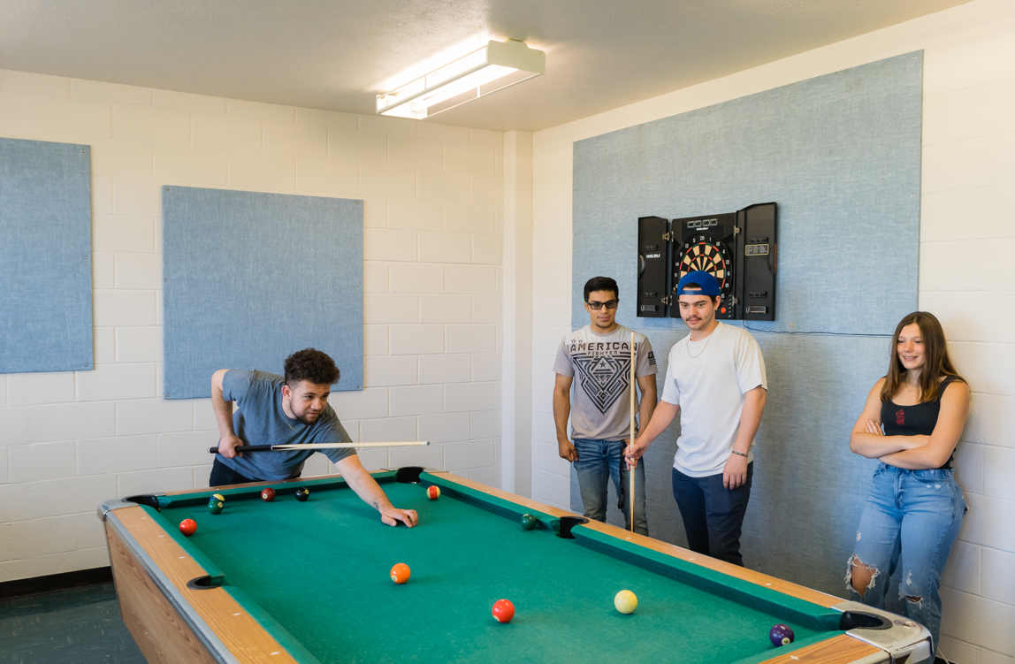

APPEALS
Appeals contesting recommendations for disciplinary action(s) must be made in writing to the DRH & Residential Life within 20 calendar days after the resident has been notified of the action from which he/she has a right of appeal. Upon reviewing the appeal, the DRH shall consider all the evidence and make a final decision. The DRH will notify the former resident of the decision within 10 days of the receipt of the appeal.
BBCC residence hall disciplinary procedures and sanctions does not preclude the enforcement of any other college policies.
If an individual resident is evicted from the residence halls, he/she may appeal but cannot reside in the residence halls during the appeal process of contesting recommendations for disciplinary actions.

FINES
This section describes fines for violating Community Standards as determined by the College.

The College may assess fees against the resident for both minor and major infractions as set forth below.

Additional fees and fines may apply as outlined in specific Community Standards.

MINOR INFRACTIONS
Violation of any Community Standard outlined in the Residence Hall Handbook unless noted as a Major Infraction
$50 fine or an educational sanction and a HOLD on the resident’s academic student account until paid.

MAJOR INFRACTIONS
Violation of Community Standards in the Residence Halls Handbook outlined as Major Infractions

Two Minor Infractions of the same Community Standard constitute a Major Infraction

Any three different Minor Infractions constitute a Major Infraction. After two Minor Infractions, the third infraction will become a Major Infraction

Any Major Infraction may result in the immediate termination of this Contract, $150.00 fine, a HOLD on the resident’s academic account and a meeting with the DRH.

TERMINATION AND MODIFICATION
TERMINATION BY THE COLLEGE
Upon determining the resident is in violation/breach of this Contract, the College may immediately terminate this contract.
19.1 Resident will be in breach of this Contract if the resident no longer meets the eligibility requirements, violates any term of the Contract, is subject to suspension or dismissal pursuant to the Student Conduct Code, WAC 132R-04, engages in activities that endanger their health, safety or welfare or the health, safety, or welfare of other residents, violates the terms of the Residence Hall Handbook and/or college policies, state, federal, or local laws, or the resident’s student account is delinquent beyond three weeks (see LATE FEES page 14).
19.2 In addition to the termination of this contract, violators may also be subject to disciplinary action under the Student Code of Conduct and criminal or civil prosecution.
19.3 BBCC reserves the right to terminate the Residence Halls Housing Contract of a resident or take additional action due to the misconduct of a resident’s guest(s).
19.4 Upon termination by the College, the resident shall complete the checkout procedures defined in this Contract and vacate the facility within the timeframe specified by authorized BBCC staff.
19.5 If this Contract is terminated, residents must vacate the facility within the 24-hour time specified by authorized BBCC staff as directed by the DRH. Failure to vacate the BBCC Residence Hall could result in your arrest for criminal trespass in accordance with RCW 9A.52.070 and 9A.52.080.
19.6 Personal belongings not removed within a 24-hour timeframe will be donated or discarded. Residents will be charged storage and handling fees at the prorated rate.
19.7 In the event illegal drugs or other controlled substances, are found in the room or in the possession of the resident and/or any of their guests is found in possession, on self or in their room or in the possession of a guest of the resident, of illegal drugs or drug paraphernalia, the housing Contract may be terminated and the resident may be given only one (1) hour to leave the Residence Halls.
RESIDENTIAL APPEALS – A resident can appeal the determination that they have breached this Contract by filing an appeal with the DRH within 20 days of the notice of termination of this Contract. The DRH will make a decision regarding the appeal and notify the former resident of the decision within 10 days of the receipt of the appeal. Removal from the Residence Halls for violations of the BBCC Student Code of Conduct may not be appealed to the DRH but must be appealed through the Student Code of Conduct process.
TERMINATION BY THE RESIDENT
If a resident wishes to terminate this Contract the resident will need to meet with the Director of the Residence Halls and complete the checkout procedures identified herein.
20.1 The effective date of termination will be the date all Billing procedures are completed.
20.2 Termination of the Contract does not excuse resident from financial consequences including but not limited to room charges for the remainder of the quarter, loss of security/damage deposit, fines, fees or cost related with collection of outstanding debts.

FINANCIAL CONSEQUENCES OF CONTRACT TERMINATION
20.3 Failure to complete the Contract for any reason will result in room charges for the entire quarter plus forfeiture of the remaining deposit.
20.4 Residents withdrawing from college for reasons of accident or extended illness, which will require extensive medical expenses, a refund of remaining room charges may be made with proper documentation from the student’s physician.
20.5 Resident will forfeit their $300.00 security/damage deposit upon Contract termination, with the exception outlined in 20.4
20.6 FINANCIAL APPEALS – A resident can appeal the determination that they have breached this Contract by filing an appeal with the DRH within 20 days of the notice of termination of this Contract. The DRH will make a decision regarding the appeal and notify the resident of the decision within 10 days of the receipt of the appeal.
20.7 Resident may appeal for reimbursement of room charges (rent) after the check-out date from termination of this Contract (check-out date)
20.8 Resident is NOT eligible for a financial appeal if termination of Contract was due to an eviction.
20.9 Resident may NOT appeal for reimbursement of the security/damage deposit

OTHER CONSEQUENCES OF CONTRACT TERMINATION
20.10 In addition to termination of the Contract (by eviction), the evicted resident is not allowed to reside or apply to the Residence Halls for a minimum of 365 days (date of eviction).
20.11 The college or Residence Halls can impose restrictions on a former resident’s visiting privileges to the BBCC Residence Halls, which includes the Residence Halls, Office, recreation room, lounges, and the adjacent area all the way to the street.
20.12 The college will provide additional notice of any restrictions on visiting the BBCC residence halls, which will include the details of the restrictions.
20.13 Violation of this notice could result in criminal charges of criminal trespass with the Grant County Sheriff’s Department.
20.14 The Residence Halls staff reserves the right to move a resident to another room or hall or remove the resident from the BBCC Residence Halls if it is in the best interest of the resident or other residents or other students of the College.
OTHER TERMS AND CONDITIONS
21.1 Student agrees to all terms and conditions of this Contract and acknowledges this Contract is binding once the student signs and submits it to the DRH. Student agrees that all charges in this Contract are a reasonable approximation of BBCC’s administrative costs and acknowledges he/she will be financially responsible for all payments required by this Contract.
21.2 This Contract is personal to the resident and is not transferable by the resident. Residents under the age of 18 years at the time of move-in must obtain the signature of their parent or legal guardian, with the exception of emancipated minors recognized as legal adults by the state of Washington.
21.3 This Contract is for an assigned space in a residence hall and not for a specific room or bed. This Contract is not a Lease. It is a license for the use of an on-campus residence as assigned by the College.
21.4 Upon acceptance of this Contract, the resident agrees to abide by the terms and conditions of this Contract, the BBCC Student Conduct Code, and applicable state, federal and local laws/regulations, as they now exist or as amended throughout the term of this contract. These regulations, policies and laws are herein incorporated. The resident understands that failure to comply with these obligations may constitute a breach of this Contract and result in its termination.
21.5 This Contract is not valid unless it has been offered through the BBCC Residence Halls Office application process. It will be declared void and null should such an unapproved Contract be attempted.
21.6 Concurrent to, or separate from, any disciplinary proceedings, the DRH, or designee, may deny or revoke housing privileges to any resident found in violation of the provisions of this contract; this includes moving residents to other rooms or halls.
  - Exceptions to the Contract may be requested by petition. Petitions are reviewed on an individual basis based on personal circumstances. Exceptions granted for one provision of this Contract shall not be construed as waivers of any other provisions. The final determination of such petitions is at the discretion of the DRH & Residential Life.

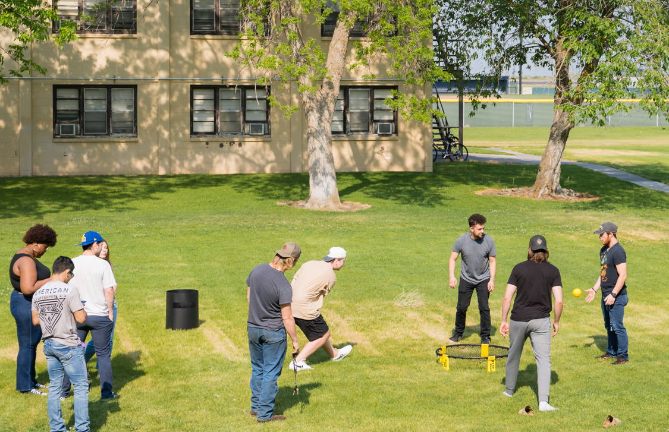

INDEX
SECTION PAGE
Alcohol & Drugs 5-6, 15, 16
Billing Rights 15
Check-Out 4
Civility 15
Commercial Solicitation, Advertising, & Promotion 19
Community Standards 3, 7, 13, 15, 21-24
Compliance ……………………………………………………………………………………. 5-6
Conduct …………………………………..…. 2, 6, 9, 11, 13, 15, 16, 17, 18, 23-27
Contract ………………………………………………….6-9,11-13,15-17,23-27 25,26
Contract Days & Breaks 4, 9, 13, 22
Contract Modifications, Breach, & Remedies 24, 25
Damage/Loss Fines & Cleaning Charges (see Fines & Fees) 9,12,17,20- 23,25,28
Dangerous Devices 20
Definitions 9
Disciplinary Procedures & Sanctions 3, 4, 17,19, 21-24
Drug-free/Alcohol-free/Room Entry Agreement 26
Eligibility 9,24
Equipment Use 20
Eviction 11, 14-16, 20, 21, 23, 27
Exception to the Contract 9, 22, 25-27
Facilities 3, 10, 17
Financial Obligation Agreement 26
Fines & Fees 24
Fire Safety 8, 17
Guests 15,17, 21,22, 25
Residence Halls Contract 1,2,9-13,15, 16, 18, 22-27
Residence Halls Payments & Fees 14
Immunization Requirements 4
Interruptions of Service 7
Keys 9
Liability 21
Lost & Found Items 21
Mail 4, 7, 9, 13
Meningococcal Meningitis Vaccine 4-5
Payment Options & Deadlines 9, 13, 14, 26
Pets 16
Quarter Arrival Dates 11
Room & Hall Care 15
Room Application 9,10
Room Assignments 11
Roommate Vacancies 10
Security 4-9, 19, 20, 23, 25,26
Sexual Assault………………………………………………………………………………….. 8
Smoking 17
Storage 17,18, 21, 25
Termination of Contract 26
Terms & Conditions 2,25-26
Theft 20
Unpaid Debts 13,22,26

