Theory of Flight
Homework 3

Name:_______________________________________ Date:_______________

1. Lift on an Airplane acts:
a. Parallel to the flight Path
b. Parallel to the relative wind.
c. Perpendicular to the flight path
d. None of the above.

2. Drag on an aircraft acts:
a. Parallel to the flight Path
b. Perpendicular to the flight path.
c. Perpendicular to the relative wind
d. None of the above.

3. The relative wind on an aircraft is
a. Parallel to the horizon
b. Perpendicular to the horizon
c. Opposite to the flight path
d. 1/2 of the Angle of attack

4. A 100-pound weight is resting on a 60° ramp and is restrained by a rope. The coefficient of friction μ = 0.35.
What is the tension force of the rope?
Sin 60° = 0.866
Cos 60° = .5 60°
Tan 60° = 1.73

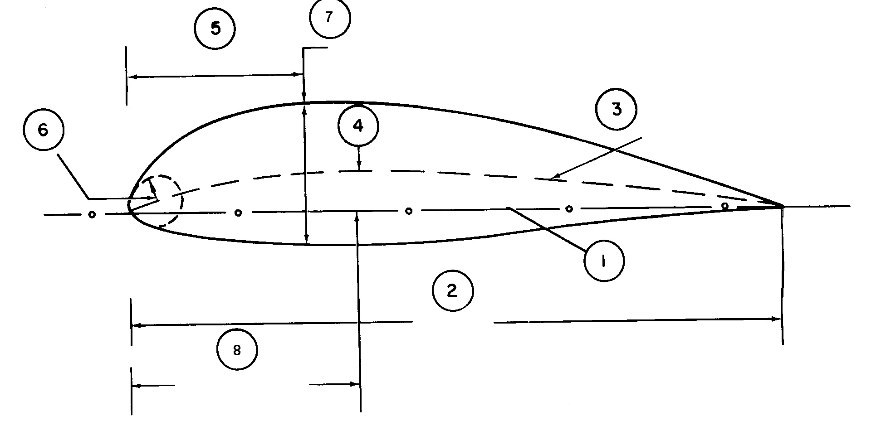
5. Fill in the corresponding number which represents the:
Chord line = _____
Mean camber line = _____
Maximum camber = _____
Location of maximum camber = _____
Location of maximum thickness = _____

6. For a cambered airfoil, the center of pressure, CP:
a. Moves to the rear of the wing at low AOA.
b. Moves backward as AOA increases.
c. Moves forward as AOA increases.
- Both a. and c. above.

7. Given the Lift equation, what are the four major factors in producing lift.
1.
2.
3.
4.

8. As camber on an airfoil is increased it’s C_{L} at any α:
a. Is less.
b. Remains the same.
c. Is greater.

9. An aircraft at 10,000 lb has a stall speed of 120 kts, what is the stall speed of the same aircraft at 8,000 lb?

10. Solve the Lift equation for ”V” and then determine Indicated stall speed for an airplane under the following conditions:
C_{L} max = 1.5
Wing area = 200 square feet
Weight = 3500 pounds
Air density = 0.001665 slugs per cubic foot

11. An airplane flying at 120 kts TAS with a C_{L} of 0.5 and wing area of 225 square feet will produce ___________ amount of lift if the air density is 0.0023 slugs per cubic foot.

12. The no flap C_{Lmax} of a 3800 pound airplane is 0.9 and the wing area is 200 square feet. What is the IAS stall speed at sea level?

13. Compute the sea level stall velocity for the T-38 given the following information:
weight = 12,000 pounds
C_{L max} = 0.94 (full flaps)
Wing area: 170 square feet
Load Factor: 1.0

