Big Bend Community College

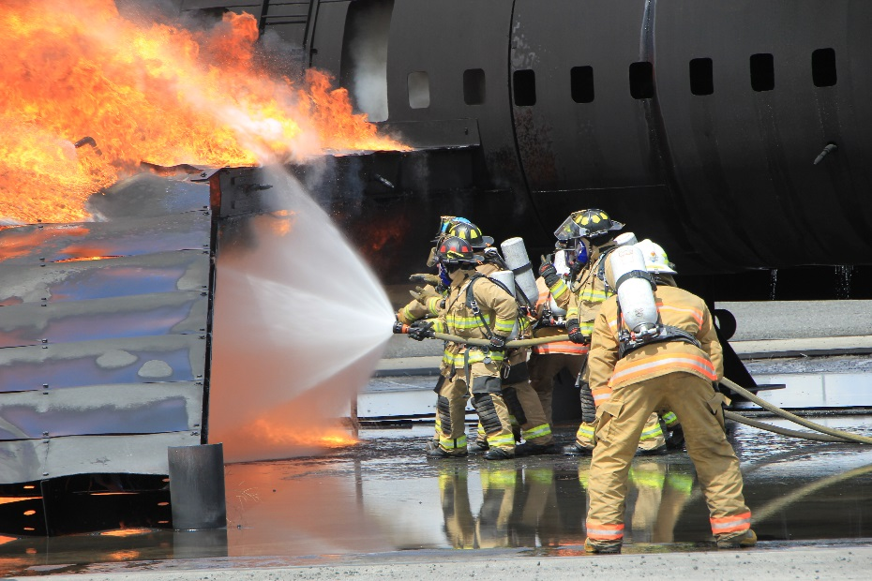
Aircraft Rescue and Fire Fighting (ARFF) Training Programs

Our mission is to provide the aviation community education and practical experience in Aircraft Rescue and Fire Fighting. By using the latest techniques each student will gain knowledge and experience in this complex emergency environment. They will take home the knowledge and confidence needed to perform effectively during an aircraft incident.

5 DAY ARFF Basic Certification Training
(Meeting FAR 139.319 guidelines)

Use of diesel fuel and Dry Chem provides the most realistic experience available!
- PPE and SCBA must be provided by the student. BBCC will provide air to fill SCBA bottles at no charge. Rentals available if needed –pricing available upon request.
- Workbook and reference info provided as a resource to you.
- Boxed Lunch provided on Day 4 and 5. (Breakfast and Dinner at own expense)
Participants may train with other fire departments in order to take advantage of best pricing. If you prefer a customized class – minimum requirements must be met.
$1725 per person (8 minimum required)
Our 5 Day Basic Training course includes:

Days 1 – 3… To include Safety Briefings and In Class Instruction (Aircraft Familiarization, Tactics and Strategies, Extinguishing Agents, Hazardous Materials and Dangerous Goods, Forcible Entry/Tools, Search and Rescue, and Fire Stream Application.)

Day 4… Hose Handling, Hand line and Truck Tactics – wet Hose drills with no fire. Search and Rescue training using smoke filled fuselage, Forceable entry experience. Live 737 slide deployment tour of civilian aircraft and 727, tour of aircraft maintenance hangar with hands on demo of aircraft systems and parts including doors, off road driving of Oshkosh 1500 crash truck.

Day 5… Live Fire Drills (Fire Stream Application, Drills with Hand lines only include training foam, T-1500 ARFF vehicle)
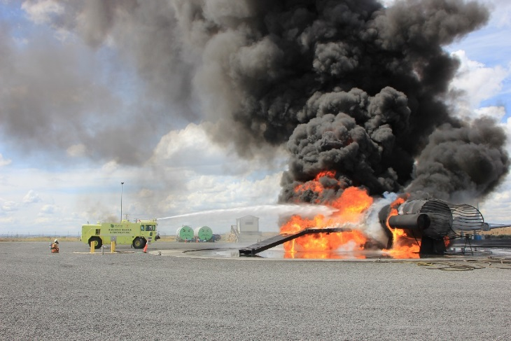
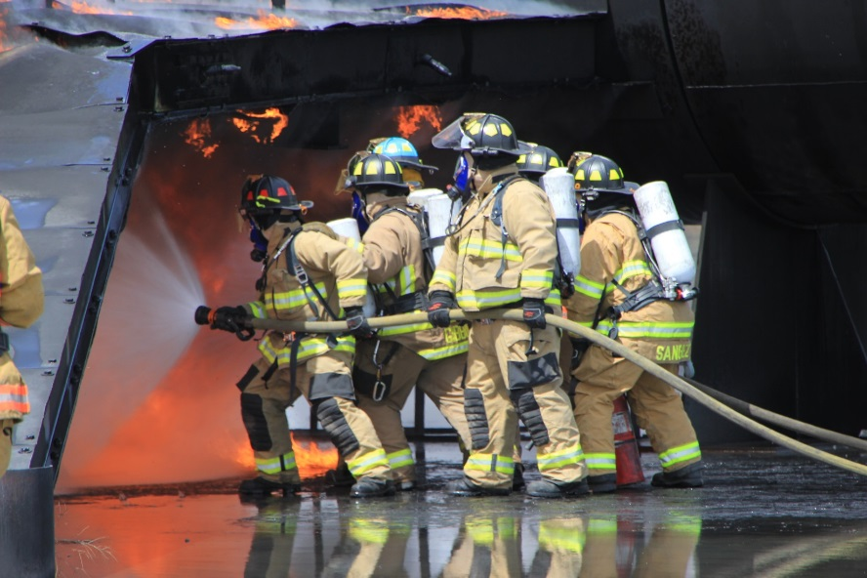
Big Bend Community College
Aircraft Rescue and Fire Fighting (ARFF) Training Programs

Our mission is to provide the aviation community education and practical experience in Aircraft Rescue and Fire Fighting. By using the latest techniques each student will gain knowledge and experience in this complex emergency environment. They will take home the knowledge and confidence needed to perform effectively during an aircraft incident.

Includes:
- Safety Briefings
- Live Fire Drills including the use of diesel fuel for the most realistic experience available! (Fire Stream Application, Drills with Hand lines, T-1500 ARFF vehicle)
Boxed Lunch and water provided!
Participants may train with other fire departments in order to take advantage of best pricing. If you prefer a customized class – minimum requirements must be met.
8 hour Re-Certification Training (meeting FAR 139.319 guidelines)

6 – 11 Trainees…$995 per person
12+ Trainees… $925 per person (20 maximum)

Dry Chem and Training Foam is available as an add-on service to your training experience:
Dry Chem - $50 per person
Training Foam - $75 per person for use with hand lines only
Training Foam - $410 per person for use with Truck Ops
PPE and SCBA must be provided by the student. BBCC will provide air to fill SCBA bottles at no charge.
Rentals available if needed. Pricing available upon request.

