**Institutional/Program Outcomes Crosswalk to Courses**

**Gen Ed/Institutional Outcomes:**

1. Students will be able to communicate clearly and effectively.
2. Students will be able to reason mathematically.
3. Students will be able to solve problems by gathering, interpreting, combining and/or applying information from multiple sources.
4. Students will be able to recognize or articulate personal/interpersonal aspects of, or connections between, diverse cultural, social, or political contexts.
5. Students will be able to demonstrate teamwork, ethics, appropriate safety awareness and/or workplace specific skills.

**AAS: Agriculture Tech & Mgmt:**

1. Students will show knowledge of workplace safety when handling food, chemical/pesticides, and equipment.
2. Students will select and use the appropriate precision and software application technology.
3. Students will demonstrate critical-thinking and problem-solving skills as they make decisions in agricultural management situations
4. Students will demonstrate knowledge of scientific principles when applied to a variety of crop production systems
5. Students will be able to communicate clearly and effectively within a workplace context.
6. Students will be able to reason mathematically using methods appropriate to the profession.
7. Students will be able to demonstrate teamwork and/or workplace specific skills related to human relations.

**AAST: Agriculture**

1. Students will demonstrate knowledge of scientific principles when applied to a variety of crop production systems.
2. Students will demonstrate critical-thinking and problem-solving skills as they make decisions in agricultural management situations
3. Students will be able to communicate clearly and effectively within a workplace context.
4. Students will be able to reason mathematically using methods appropriate to the profession.
5. Students will be able to demonstrate teamwork and/or workplace specific skills related to human relations.

**Cert: Agricultural Business**

1. Students will demonstrate critical-thinking and problem-solving skills as they make decisions in agricultural management situations
2. (PO8) Students will demonstrate knowledge of business principles when applied to agricultural businesses and operations
3. Students will be able to communicate clearly and effectively within a workplace context.
4. Students will be able to reason mathematically using methods appropriate to the profession.
5. Students will be able to demonstrate teamwork and/or workplace specific skills related to human relations.

**Cert: Agricultural Unmanned Systems**

1. (PO 9)Students will select and use the appropriate precision and software application technology
2. (PO 10)Students will collect and evaluate data from various technologies and make management decisions from the data collected.
3. (PO 11)Students will apply the rules, protocols, and safety required to operate an unmanned aerial system for commercial agriculture purposes
4. Students will be able to communicate clearly and effectively within a workplace context.
5. Students will be able to reason mathematically using methods appropriate to the profession.
6. Students will be able to demonstrate teamwork and/or workplace specific skills related to human relations.

**Cert: Agronomy**

1. (PO12) Students will apply plant and soils science concepts to crop production.
2. Students will demonstrate critical-thinking and problem-solving skills as they make decisions in agricultural management situations
3. Students will be able to communicate clearly and effectively within a workplace context.
4. Students will be able to reason mathematically using methods appropriate to the profession.
5. Students will be able to demonstrate teamwork and/or workplace specific skills related to human relations.



NOTE: For Programs, your “Outcomes Crosswalk to Courses” will be related to your specific Program Outcomes. You will need to list your outcomes and adjust the chart accordingly.

(For the workforce programs, you need to crosswalk your courses with the program outcomes. Last fall, you updated the program outcomes to ensure that the Institutional (then called Related Instruction) outcomes of Communication, Computation, and Human Relations were either embedded in the program outcomes or added to them. As a result, all you need to do is make sure that you are addressing each of the program outcomes and you are also hitting the Institutional Outcomes. You should already have it done in the (or mostly done) from the work you did previously in their Excel sheet assessment plans on the Canvas page. Moving forward, faculty should be able to just update the document each fall when they are doing their assessment plans for the year).

**7-Year Department/Program Assessment Plan Template**

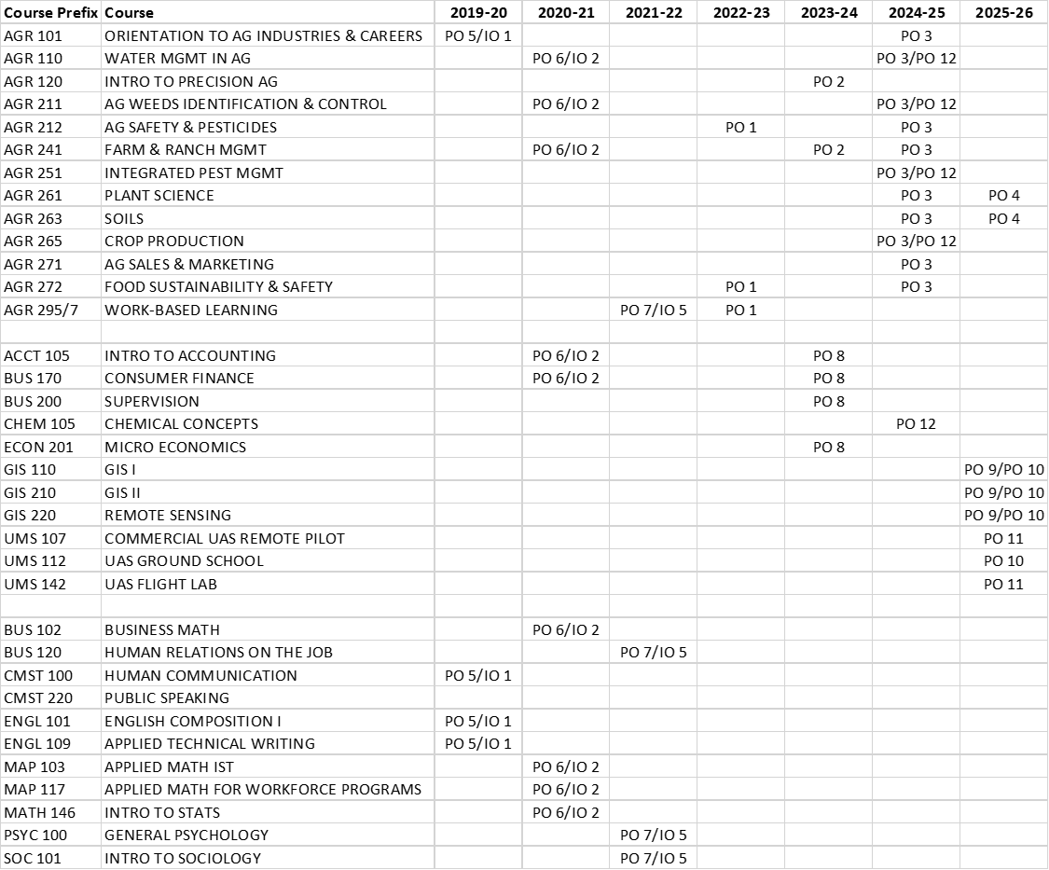

*List the Gen Ed (GE) which will be assessed, in the cross-section of the “course” row and the “year assessed” column.

**You can find the Gen. Ed.s listed for each course, on the course MCOs. Course MCOs can be found on the Faculty Portal. Most programs/departments have already created a “Gen Ed to course” crosswalk in the 7-year Excel Workbook created under Dr. Leonard 3 years ago.