

***Big Bend* COMMUNITY COLLEGE**

## COMMERCIAL PILOT PROGRAM

Thank you for your interest in the Commercial Pilot Program at Big Bend Community College!

### HISTORY

The Big Bend Community College Aviation Program is an FAA authorized commercial pilot training program, which started in 1965 with 23 students and 3 airplanes. Today, there are approximately 100 students, 26 aircraft, 2 simulators, and 10-14 full-time instructors. During our two-year program, an average student will fly 250 hours to gain a commercial pilot certificate with an instrument rating. Aviation training at Big Bend is taken in conjunction with academic or vocational courses that the student chooses; to fulfill the requirements of the ***Associate in Arts and Science*** transfer option and the ***Associate in Applied Science-Commercial Pilot***. Most students will complete both degrees simultaneously without any additional costs. All students who complete Big Bend’s aviation program will receive the ***Restricted-Airline Transport Pilot (R-ATP)*** authorization, which will lower the ATP certificate requirements by 250 hours and allow them to enter the industry more rapidly.

### OPTIONS

One of the many advantages of attending Big Bend’s flight program is that upon completion, you will have many options available. One option is to go immediately into a flight career. You will have the best training available and will have Big Bend’s reputation which is respected by employers worldwide. Today, many major airlines no longer require a bachelor’s degree. Getting into the industry as soon as possible allows for higher seniority and quicker upgrades when compared to those that went to a university. Simply having an extra two years available for income when approaching retirement can mean an increase of several hundred-thousand dollars in potential income. Another option is to transfer to any four-year college or university to receive a degree in an aviation field or in another area of interest. Currently, the online bachelor’s degrees offered through Big Bend Community College or other universities are the most popular option among our students. This allows the option to be paid while accumulating flight hours and finishing your degree. It also allows a student to obtain a degree in a field that they choose, should they not be able to continue flying. Completing an online bachelor’s degree can be done at a reduced cost, while getting into the industry as quick as possible.

### THE FLEET

Our fleet offers excellent training for the students. Fourteen are four-place, fully instrumented Beechcraft Sports and Sundowners. We also have three 285-horsepower Beechcraft Bonanzas with retractable gear and a constant-speed propeller for high performance and complex training. A Citabria is used to give tail wheel experience and to offer spin training. Additional training is available in a Cessna 180 amphibious floatplane. Five Piper Archers and two Piper Warriors offer “glass cockpit” training to ensure the students receive the most advanced training possible. A “glass cockpit” Piper Seminole is used for multi-engine training. Students will perform instrument training in both traditional “steam gauge” as well as in “glass cockpit” aircraft. Training includes advanced instrument procedures in aircraft that have access to weather/radar and traffic information, as well as the latest GPS/WAAS approach technology. Simulators that replicate the training aircraft are used to enhance training and increase cost efficiency.

### AIRPORT FACILITIES

We fly from the best training airport in the Northwest—if not the world. In addition to Big Bend, the airport is used as a training and testing facility for Boeing, the United States military, as well as other companies. Jet traffic is sufficient to indoctrinate our students to large aircraft operations while still providing plenty of space for efficient and safe training. Airport and radio facilities are unsurpassed, with ATIS, two tower frequencies, ground control, approach control, and the on-field radar (TRACON) facilities. All Air Traffic Control facilities are FAA operated. The airport has 5 runways including one that is 13,503 feet long and 15 instrument approaches. We also have the use of 5 other airfields within 25 miles and 30 airfields within 75 miles of our airport. Our students will often experience some of the highest concentrations of traffic available—5 or more aircraft in the pattern following a Boeing 787; and moments later, land at a small rural strip where they are the only aircraft in sight.

### FLIGHT STAFF

The BBCC senior staff have a variety of industry experience and teach in the aircraft and in the classroom. Our senior flight instructors have over 50,000 hours of flight experience and have over 75 years of combined instruction experience at Big Bend alone! Our Junior Flight Instructors are students who have completed our program, went on to complete their flight instructor training, and were selected to supplement our flight training. Selected students can have a great starting job in the aviation industry while gaining flight hours and, if they choose, complete their bachelor’s degree.

### FLIGHT CURRICULUM

Our flight curriculum consists of a minimum of 195 hours of flying and simulator time. If the course is completed in an average length of time, the student will have 220 hours of flying time and 30 hours of simulator time. The flight lab fee should be approximately $6,500 per quarter (fees are subject to change without notice). This quarterly fee pays for approximately 15 hours of dual, 15 hours of solo flying, and four hours of training in simulators. Ten to fifteen hours of complex, high performance flying is also scheduled in one quarter during the second year at an increased rate. Flight fees are paid in advance into the student’s flight account and students must maintain a positive balance before flying. Our program is designed to graduate successful students with a Commercial Pilot Certificate with an Instrument Rating within two academic school years. BBCC’s FAA examining authority means that students can progress as their competency allows without having to wait or pay for FAA check rides.

### GROUND SCHOOL

The ground school courses are taught by our senior instructors and include approximately 230 hours of formal classroom instruction divided among seven required subjects. Ground school classes are conducted in the late afternoon and evening, allowing students to fly the aircraft and receive instruction from the same instructors. This also allows the students to integrate flight and ground school training into their college class schedule. We also have three optional ground schools to increase knowledge in aircraft systems, advanced weather theory, and flight instruction fundamentals.

### COURSE SEQUENCE

All new students attend a special one-week Pre-Flight Ground School, which begins one week prior to the normal college starting date. To ensure students who complete the program have the background skills and knowledge necessary to fly safely, ground school and flight courses are sequential and required. Students can only enter the program at the beginning of the fall quarter. Those with flight experience may complete flight lessons in a more timely manner and excel through the program.

### COMPLETION

The aviation program is an intense program. Most of the students will be taking a full load of college courses (approx. ten credits per quarter) in addition to nine aviation credits (19 total credits per quarter). This allows the student to receive their commercial certificate and instrument rating while receiving their associate degree. Not all students will successfully graduate from the Aviation Program. Various factors can prevent completing the program including (but not limited to) a lack of funding, time, or progress. Admission to the program does not imply a guarantee of successful completion, graduation, or of receiving our FAA certification. Students must meet FAA requirements and specific program progress gates.

### EMPLOYMENT AND FURTHER EDUCATION

Our graduates are employed throughout the United States in all areas of the aviation industry. BBCC has pilots that have gone on to become astronauts, test pilots, military pilots, or fly for just about every U.S. airline. Several fly jets for large corporations or corporate charter operators. The aviation industry and all related areas need qualified pilots! Hiring trends and forecasts indicate excellent opportunities for well-trained pilots in the years ahead. Because of our experience of over 50 years and our well-earned respect in the aviation industry, our students have many different opportunities with many different operators when they complete their training. For some, BBCC’s junior flight instructor program provides an excellent opportunity to instruct in an established program and gain flight time while being paid for doing what they love to do. Many will earn their bachelor’s degree while they are accruing hours.

Upon graduation from the program and completion of their associate degree, students will receive a Restricted-ATP certificate authorizing them to have a 250-hour reduction from the 1,500-hours requirement for an airline transport pilot certificate. With the completion of a qualified bachelor’s degree, there is the opportunity to reduce the requirement by another 250 hours (for a 1,000 minimum time requirement). However, with the two-year head start, many of our students will achieve the necessary 1,250 hours before they receive their bachelor’s degree. Because of this, many students will pursue a bachelor’s degree in a field other than an aviation “pilot” degree while they are in their first two years of employment. Having a degree in something other than piloting an aircraft (such as aviation-management, aviation- logistics supply, communication, leadership, etc.) from an aviation college or other university allows a certain level of security should a pilot lose their medical or ability to fly.

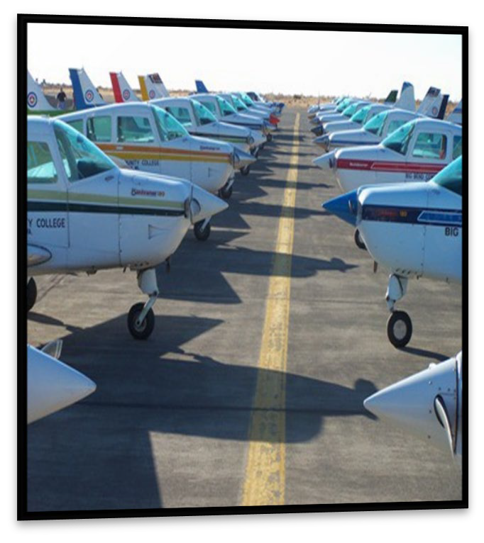

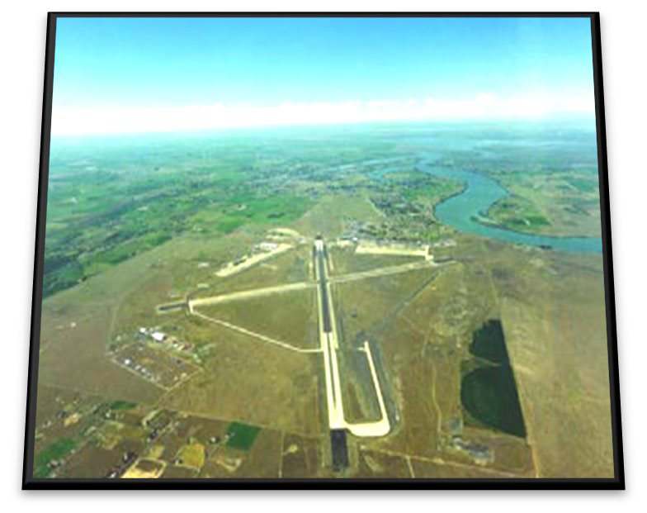

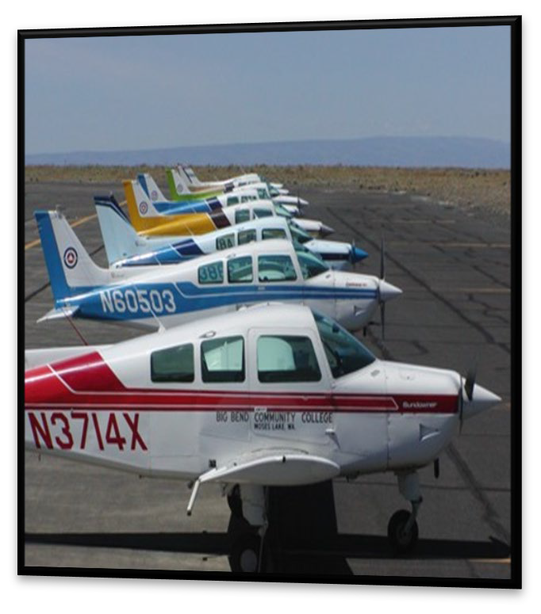

If you have other questions or would like to schedule a tour, please contact the Flight Training Center at 509.793.2241.

#### We want to be part of your aviation education and career!

***Big Bend* COMMUNITY COLLEGE**

*COMMERCIAL PILOT PROGRAM*

# ADMISSION CHECKLIST

***MINIMUM REQUIREMENTS TO APPLY TO ENTER THE COMMERCIAL PILOT PROGRAM***

Applications will be accepted beginning **November 1** for the following years program

1. Complete the Big Bend Community College online application for admission beginning November 1stfor the following fall. Visit our website at [https://www.bigbend.edu,](http://www.bigbend.edu/) select “I AM”, and choose the appropriate sub-title.
2. Financial Aid – (Optional) Highly Recommended
   * Bigbend.edu
   * Hover over “Student Center”
   * Select “Financial Aid”
   * You may also contact them by email at [faidinfo@bigbend.edu](mailto:faidinfo@bigbend.edu) or 509.793.2088
3. Scholarships – (Optional) Big Bend Community College Foundation offers approximately 100 scholarships. Fill out one application and apply for the ones in which you meet the criteria.
   * Visit <https://www.bigbend.edu/i-am/foundation/>
   * Scholarships
   * Online Scholarship Application
4. Complete and sign the Aviation Questionnaire (included in this packet)
5. Transcripts: High school and/or college transcripts that you have attended. The Admissions Office will need Official College transcripts. Most schools require your signature and a fee for official transcripts. Check your previous school’s website or call them to find out their procedure. Submit a high school transcript to the testing center for placement evaluation, [**Placement Evaluation Request (PER)**](https://www.bigbend.edu/i-am/placement-evaluation-request/)
   * APPLYING TO THE PROGRAM WITH A HIGH SCHOOLDIPLOMA
     + Cumulative grade point average (GPA) of 2.0 or higher
     + Completed at least one year of algebra
     + Completed three years of English
   * APPLYING TO THE PROGRAM WITH AGED OR HOME-BASED INSTRUCTION
     + Minimum score of 145 on the Writing Skills Test
     + Minimum score of 145 on the Mathematics Test
   * APPLYING TO THE PROGRAM WITH 15 OR MORE COLLEGE CREDITS

* Cumulative GPA of 2.0 or higher
  + INTERNATIONALAPPLICANTS
    - Meet BBCC entrance requirements for International Students
    - Meet the English Skill Requirements set forth in the FAA Advisory Circular AC 60-28B dated 06/02/2017

**A REVIEW PANEL WILL CONSIDER APPEALS FROM APPLICANTS WHO DO NOT MEET THE ABOVE REQUIREMENTS**

1. A **photocopy** of your valid FAA Class I or Class II medical without the notation "not valid where English is required" or any other notations that would prohibit you from operating as a commercial pilot (no night flying, no controlled airspace, etc.). **Class III medicals will not be accepted** since they cannot be used for commercial purposes.

The classes signify the operations that you can perform. For example, a Class II is necessary to earn money flying an aircraft, while a Class I is required to earn money flying for an airline or to be the pilot in command of a jet aircraft. For training purposes, Class I and Class II medicals are valid for five years for someone under 40 years of age.

You must get your Class I or Class II from an Aviation Medical Examiner. Some examiners can only certify certain classes. Make sure your AME can certify an FAA Class I or a Class II aviation medical. Before your appointment, you’ll need to create an account with the FAA MedXPress. [https://medxpress.faa.gov/medxpress/.](https://medxpress.faa.gov/medxpress/) You’ll want to print the document and code for your appointment.

**Note:** to find an Aviation Medical Examiner please visit <https://www.faa.gov/pilots/amelocator>

1. **A photocopy** of your birth certificate & photo ID; or current passport; or naturalization certificate and photo ID.

**Note:** We only need photocopies with your application. **When you show on the first day, you must have the original documents (birth certificate or unexpired passport) that prove citizenship**.

1. Submit the above documents to:

Big Bend Community College Aviation Training Center

7662 Chanute Street, Building 3000 Moses Lake, Washington 98837

Or

Email copies to Debbie Simpson, [debbies@bigbend.edu](mailto:debbies@bigbend.edu) (Remember, you’ll need your **original** documents on the first day of class).

1. A $500 flight deposit will be required before official acceptance into the Commercial Pilot program is complete. Once your file is complete a Refund Policy will be emailed. You will need to sign, return, and pay the deposit. This deposit is used to open your flight account and will be used when you begin flying.

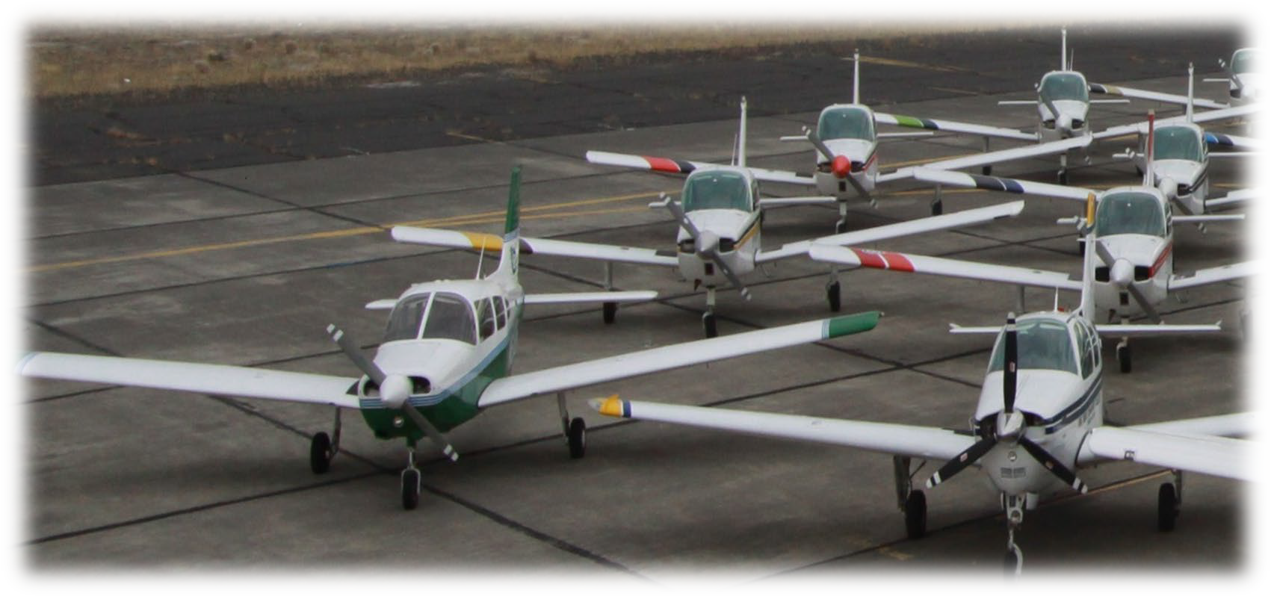

***Big Bend* COMMUNITY COLLEGE**

*COMMERCIAL PILOT PROGRAM*

# PROCESS OF REGISTRATION

## After you have applied and been admitted into the program, follow these steps to be registered for the fall quarter.

#### Take the placement exams

Math and English placement exams are administered by appointment though the BBCC testing center. You will need to have picture identification and student id number if you've already been admitted. More information and other placement options can be found at [https://www.bigbend.edu/student-center/testing-center/.](https://www.bigbend.edu/student-center/testing-center/)

#### Attend a New Studen[t Enrollment Session](http://www.bigbend.edu/foundation) (NSE)

New Student Enrollment (NSE) sessions are held several times throughout the summer for the following fall and once before winter and spring quarter. Once you have been admitted to the college you will receive additional information regarding the online Viking Orientation and how to sign up for a New Student Enrollment session. During NSE you will learn important information about BBCC, receive academic advising and be allowed to enroll into classes. If you do not attend NSE, you will register during open registration according to the time listed in the quarterly class schedule, which is available online. You will need to contact an advisor before you will be able to enroll in classes. To make an appointment contact the Admissions/Registration Office, 509.793.2061. Other aviation questions should be directed to our Aviation Program Coordinator at 509.793.2241, [debbies@bigbend.edu.](mailto:debbies@bigbend.edu)

#### Advising

Students with 30 or less transcript credits are required to meet with their advisor to remove any advising blocks before enrolling. Once you’ve attended New Student Enrollment session and enrolled for classes, your advisors name will appear at the top of your schedule. You will not be able to enroll during your date/time without having the block(s) removed.

#### Pay tuition and fees

Your tuition payment is due by the tuition due date each quarter (see the Academic Calendar under the Academic drop-down menu). You must pay your tuition or sign up for the Step Payment Program by the due date to avoid being dropped from classes. Financial aid awards are normally posted to your account on or before the tuition due date. Tuition may be paid by cash, check, or credit card through the Business Office, 509.763.2018 or by selecting the Financial Account Tile through you CTClink account. When adding funding into your flight account, you must contact the Business Office (509.793.2024) with your Student ID#.

***Big Bend* COMMUNITY COLLEGE**

*COMMERCIAL PILOT PROGRAM*

# APPROXIMATE COSTS PER QUARTER

### BASED ON AVERAGE FLIGHT TIMES (NOT MINIMUM) AND COMPLETION OF THE AA&S TRANSFER DEGREE

This sheet will give you an idea of the cost to attend the Big Bend Community College Flight Program. It is designed to show the *average cost* of the program (not minimum) and assumes that you will be completing the AA&S transfer degree. The cost also assumes that you will live in the college dormitory and will cook your own meals. **Out of state students should add approximately $140 per quarter and international students should add $2100 per quarter for tuition expenses.** The AVF courses in parenthesis are estimated for planning purposes only and may be different for some students depending on progress.

|  |  |  |  |
| --- | --- | --- | --- |
| **Fall Quarter** - 1st year |  | **Fall Quarter** – 2nd year |  |
| Tuition (20 credits) | 2,204.00 | Tuition (19 credits) | 2,079.00 |
| Textbooks | 400.00 | Textbooks | 400.00 |
| Insurance (fall quarter  only) | 140.00 | Insurance (fall quarter only) | 140.00 |
| Lab Fees a/c rentals | 7,500.00 | Lab Fees a/c rental | 7,500.00 |
| Residence Hall | 1,150.00 | Residence Hall | 1,150.00 |
| Headset & Supplies | 580.00 | FAA Written (Instrument) | 175.00 |
| FAA Written (Private  Pilot) | 175.00 |  |  |
| Total | **12,149.00** | Total | **11,444.00** |
| **Winter** **Quarter**– 1st year |  | **Winter Quarter** – 2nd year |  |
| Tuition (20 credits) | 2,204.00 | Tuition (19 credits) | 2,079.00 |
| Textbooks | 350.00 | Textbooks | 350.00 |
| Lab Fees & a/c rentals | 7,500.00 | Lab Fees a/c Rentals | 7,500.00 |
| Residence Hall | 1,150.00 | Residence Hall | 1,150.00 |
|  |  | FAA Written (Commercial) | 175.00 |
| Total | **11,204.00** | Total | **11,254.00** |
| **Spring Quarter** – 1st year |  | **Spring Quarter** – 2nd year |  |
| Tuition (19 credits) | 2,079.00 | Tuition (19 credits) | 2,079.00 |
| Textbooks | 300.00 | Textbooks | 350.00 |
| Lab Fess & a/c rental | 7,500.00 | Lab Fees a/c rentals | 7,500.00 |
| Residence Hall | 1,150.00 | Residence Hall | 1,150.00 |
| Total | **11,029.00** | Total | **11,079.00** |
| **Summer Quarter** – complete Stage 3 | | **Summer Quarter** – complete Stage 7 | |
| Tuition (12 credits) | 1,525.00 | Tuition (12 credits) | 1,525.00 |
| Textbooks | 120.00 | Textbooks | 120.00 |
| Lab Fees & a/c rental | 8,700.00 | Lab Fees a/c rentals | 8,700.00 |
| Residence Hall | 1,150.00 | Residence Hall | 1,150.00 |
|  | **11,495.00** | Total | **11,495.00** |
| **TOTAL 1ST YEAR ESTIMATE** | **$45,877.00** | **TOTAL 2ND YEAR ESTIMATE** | **$45272.00** |
|  | Total Program Cost Estimate: | **$91,149.00** |  |

This is intended to help you plan for the **2026-2027** school years. **All information is approximate and is subject to change without notice. It represents high average, realistic costs and not FAA minimum flight times.** While summers are optional, most students find it necessary to attend at least one. Students who complete the Commercial/Instrument certificate and add the Flight Instructor certificate, or an additional rating such as Multi-engine, usually will attend two summer quarters. **Additional Time and Ratings (Based on average completion times and average examiner’s fees)** Multi Engine (Piper Seminole) **$3,850** CFI (20 hrs. B19 Beech & Citabria) **$6,000**

CONTACT INFORMATION

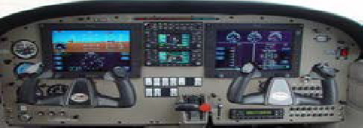

#### Need More Information on BBCC AVIATION Programs?

For additional information, you can write, call, or send an email. Be sure to include your name, address, and when you would be interested in starting the flight program.

You can write to:

BBCC Aviation Flight Center Building 3000

7662 Chanute St

Moses Lake, WA 98837-3299 Or

Call the BBCC Aviation Office, 509.793.2241 (toll free 1.877.745.1212 ext. 2241) or send an e-mail message to [aviation@bigbend.edu](mailto:aviation@bigbend.edu)

***TOURS OF OUR FACILITIES***

We encourage and recommend that you visit our facilities. Give Debbie a call (509.793.2241) and she will be happy to set up a date and time for a tour. The facilitator will be happy to explain how our program works, our curriculum, degree options, and show you our aircrafts. In addition to the tour option, we attend several air shows throughout the Northwest. We also attend many high school career fairs. Ask your school counselor for Big Bend Aviation Program information. Come check us out!

Commonly used phone numbers:

BBCC Main Phone Number 509.793.2222 Extension numbers are listed below: *

Flight Department 2241

Admissions 2089

Business Office 2018

Counseling 2035

Financial Aid 2061

*Note: All extension numbers may be dialed directly by using Area Code (509) and prefix 793-

***Big Bend* COMMUNITY COLLEGE** COMMERCIAL PILOT PROGRAM **DIRECTIONS TO OUR FACILITIES**

Coming from Seattle on I-90,

1. Take the WA-17 exit- EXIT 179 Marked MOSES LAKE/OTHELLO. 0.3 miles
2. Turn LEFT onto WA-17 N. Continue to follow WA-17 N. 7.3 miles
3. Turn RIGHT onto Randolph Road. 0.4 miles
4. Turn left on College Parkway. 0.4 miles
5. Turn LEFT after baseball fields then immediate RIGHT <0.1 miles
6. End at Building 3000, 7400 Andrews St NE, Moses Lake, WA 98837-3293. Our building is next to the last hangar with the red roof.

Coming from Spokane on I-90,

1. Take the WA-17 exit- EXIT 179 Marked MOSES LAKE/OTHELLO. 0.3 miles
2. Turn RIGHT onto WA-17 N. Continue to follow WA-17 N. 7.3 miles
3. Turn RIGHT onto Randolph Road. 0.4 miles
4. Turn left on College Parkway. 0.4 miles
5. Turn LEFT after baseball fields then immediate RIGHT <0.1 miles
6. End at Building 3000, 7400 Andrews St NE, Moses Lake, WA 98837-3293. Our building is next to the last hangar with the red roof.

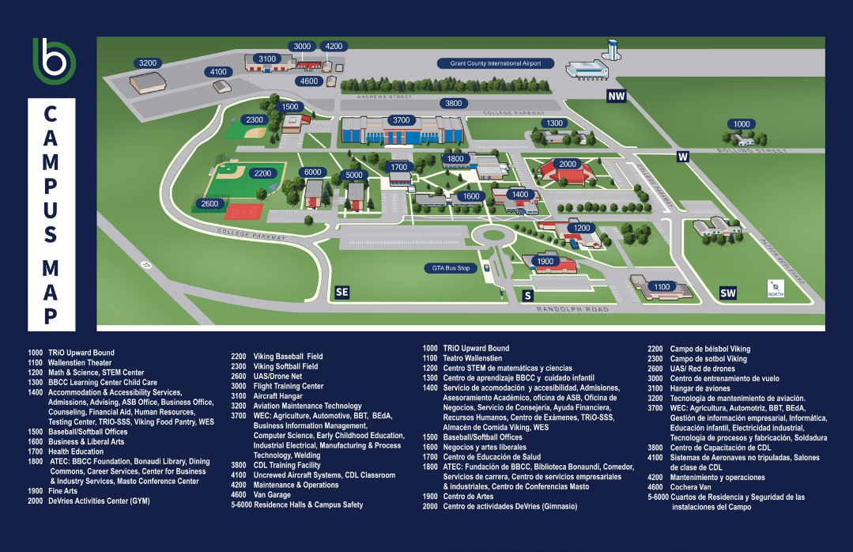

***Big Bend* COMMUNITY COLLEGE**

COMMERCIAL PILOT PROGRAM

***U.S. CITIZENS AND NATIONALS ID REQUIREMENTS***

All US Citizens and nationals must present evidence of U.S. citizenship by ***one*** of the following before you fly. For most students this will be their birth certificate and driver license, or Passport, or Naturalization Certificate and driver license. Note: check the TSA/Department of Homeland Security website closely. They are very specific on types of documents acceptable (raised seals, etc.).

**Evidence of U.S. citizenship must be shown by one of the following:**

* + Valid, unexpired U.S. passport.
  + Original birth certificate of the United States, American Samoa, or Swains Island and government-issued picture ID.
  + Original certification of birth abroad with raised seal (Form FS-545 or DS-1350) and government-issued picture ID.
  + Original certificate of U.S. citizenship with raised seal (Form N-560 or N-561), or a Certificate of Repatriation (Form N-581), and government-issued pictureID.
  + Original U.S. Naturalization Certificate with raised seal (Form N-550 or N-570) and a government-issued picture ID.

Please include a photocopy of your proof of US Citizenship with your application packet. When you show up on the first day of classes, **you will be required to present your *original*** documents for review.

*Note:* ***You will not be able to fly until*** *your* ***original*** *documents have been reviewed and an endorsement is given in your logbook from the chief flight instructor or designee. Therefore, you must bring these to the first day of school as well—even if you have already supplied copies to the college.*

|  |
| --- |
| ***Big Bend* COMMUNITY COLLEGE**  COMMERCIAL PILOT PROGRAM  **Documentation Requirements for Aliens**  TSA defines an alien as any person who is not a citizen or national of the United States. This definition includes resident aliens (green-card holders) and visa holders in the United States. These requirements also apply to aliens receiving training outside the United States for a U.S. airman certificate. **Aliens — Flight school and alien registration**  Flight school has registered with TSA for training aliens. (Note: Big Bend Community College is a TSA registered school)  Alien has registered with TSA to receive flight training.  **Aliens — Flight school recordkeeping requirements**  Flight schools and instructors that provide flight training to aliens must keep certain records for five years, including:  The photograph of the candidate (same photograph sent to TSA).  A copy of the approval sent by the TSA confirming the candidate's eligibility for flight training. (Both the candidate and the flight training provider will receive an e-mail with the subject "Permission to Initiate Training/Fingerprint Receipt" when all the required information has been received and verified by TSA).  Candidate's full name, gender, and date of birth. |
| Candidate's ID number created by TSA. |
| Copy of candidate's valid, unexpired passport andvisa. |
| Copy of all previous passports and visas held by the candidate and all the information necessary to obtain a passport and visa. |
| Candidate's country of birth, current country or countries of citizenship, and each previous country of citizenship, if any. |
| Candidate's requested dates, type, and location oftraining. |
| Candidate's current U.S. pilot certificate and certificate number (ifany). |
| Candidate's current address and phone number and each address for the previous five years. |
| Copy of receipt confirming that the $130 was paid (printable from TSA Website after candidate makes payment). |
| For DoD endorsees, a copy of the required written statement and picture ID.  *See to* [*https://fts.tsa.dhs.gov/home*](https://fts.tsa.dhs.gov/home) *apply and for specific details on this process.* |

# Options for BBCC Aviation Students

Most BBCC flight students will pursue a four-year degree. Until very recently, the major airlines and many companies gave preference to those with a bachelor’s degree. During the two years that BBCC students are learning to fly, they usually complete the Associate of Arts and Science (AA&S) transfer degree (as well as an Associate in Applied Science- Commercial Pilot). This allows them to transfer to any four-year institution and complete a degree of their choice. While some aviation jobs might prefer a bachelor’s degree, they usually do not have a preference for what subject you major in. A bachelor’s degree gives you a variety of options. Completing the first two years of general education requirements at a community college makes sense because it’s cheaper than it would be at a university. Tuition costs at BBCC can be ½ the cost per credit hour when compared to other colleges. Along with cost savings, you can complete your requirements at a reduced cost while completing your flight certificates. You can earn flight hours and income while you complete the bachelor’s degree of your choice.

BBCC students will receive a 250-hour reduction in the number of hours required for the Airline Transport Pilot Certificate upon completion of the program and the Associate in Applied Science. Because airlines require an ATP certificate, this means BBCC aviation graduates can qualify at 1,250 hours as opposed to the 1,500 minimums. In addition, students may be eligible to receive another 250-hour reduction (for a 1,000-hour minimum) if they choose to receive a qualified bachelor’s degree in aviation from a qualified institution after they complete BBCC.

Some BBCC students choose to get a bachelor’s degree in a non-aviation field. Some will pursue a degree that will still allow them to work in the aviation industry if they are unable to work as a pilot. Many universities offer online or distant learning opportunities that allow a BBCC student to complete their Bachelor’s Degree while they continue flying or work as a flight instructor here at Big Bend. This also allows the student to pursue other employment opportunities while completing their degree. Since most BBCC aviation students will complete their FAA ratings while completing their Gen- Ed requirements, many students can achieve their 1,250-hour requirement before they are able to complete their bachelor’s degree. This allows students to begin working in the industry, gain flight hours, seniority, and to pursue a bachelor’s degree of their choice at a reduced cost and timeframe. Big Bend Aviation students preserve their options and retain the ability to get into the industry quickly while receiving the bachelor’s degree of their choice.

The following is a list of different options BBCC Aviation students have while completing the program. Essential to most of these options is the completion of the Associate of Arts and Science (DTA) transfer degree. This is a powerful academic transfer tool and meets the general education requirements of most four-year degrees. It is usually the best choice for flight students to obtain a transfer degree, while completing the commercial pilot flight training. It is also recommended that BBCC Aviation students complete the optional Associates in Applied Science degree with a Commercial Pilot specialization, which can be done simultaneously—typically at no extra cost.

Option #1 Complete the Associate of Arts and Science (Direct Transfer Agreement), the Associate of Applied Science-Commercial Pilot, FAA Commercial/Instrument Rating and enter the industry

This option to complete the associate degrees and the FAA commercial/instrument certificate is the most general option and can be completed in two years. Students will need to take at least 16 credits per quarter, and depending on the number of credits transferred in, students will need to take approximately 18 credits per quarter to stay on track for completion. After completion of their FAA Commercial Pilot Certificate and Instrument Ratings, as well as the A.A.S (DTA) and A.A.S.-Commercial Pilot degrees, the student will receive the Restricted ATP 250-hour reduction. The student can then enter the industry to begin accruing flight hours and earning income.

Option #2 Add a multi-engine, certified flight instructor, or instrument instructor rating

The student can complete Option #1 and then add on a Multi-Engine Rating, Float Rating, and/or a Certified Flight Instructor Rating. The multi-rating increases the marketability of the student. Most commercial pilots will need a Multi-Engine Rating to advance in their careers.

Option #3 Gain hours and work at BBCC as an instructor

The Certified Flight Instructor Rating allows a commercial pilot to teach students and count the flight hours as well. This is a great way to earn income while gaining the necessary flight time to take you from 250 hours to the 1,250 (or 1,000-hour, or 1,500-hour depending on the requirement) hour ATP requirement. Most importantly, the CFI certificate allows the student to gain the most valuable training available and to improve as a pilot. BBCC will often hire graduates who earn their CFI certificate to teach alongside the senior instructors. This allows the graduate to gain hours towards their ATP requirements here at BBCC while being paid, and if desired, simultaneously completing a bachelor’s degree. For years, this has been a common path for select BBCC’s students to get into the industry in a quick, cost-effective manner.

Option #4 Transfer to another institution to complete your bachelor’s degree

Students may choose to complete the program and then transfer to a university to complete their bachelor’s degree. This is a great option for students who want to ensure they get a large campus experience, while preserving their ability to reduce the costs or earn income at the same time.

In previous years, this was a more common option; however, with the availability of online degrees, most students want to take advantage of the ability to enter the industry and begin accruing hours and income after two years. In an industry based on seniority, many students do not want to give up the advantages afforded by entering the industry two years ahead of those who chose a four-year option. This is especially true when considering the availability of online options.

Option #5 Complete your bachelor’s degree while here at Big Bend

Although the Airlines and many aviation businesses are removing their preference for a bachelor’s degree, the Aviation Program at BBCC still feels this is an important part of offering security during your career. The removal of the requirement for a bachelor’s degree has only increased the benefits offered to BBCC students. They have the option to work on their bachelor’s degree when they have completed their associate degree. Several colleges offer online options that are very popular. Some students will pursue degrees in an aviation-related field while others will not. One of the many advantages of BBCC is the option to receive a degree in a field that the student would like to pursue if they were suddenly unable to fly. Degrees in management, leadership, business, etc. can offer the ability to move into other areas within your company or the industry should you lose your medical. Some of these degrees can be found with an aviation element attached. Other bachelor’s degrees may have no aviation connection at all. The key is to make sure you have a degree that allows you to continue working in an area you enjoy without having to “start over”.

The Big Bend Community College commercial pilot program will give you the options to help you decide whatever method is best suited to your education needs. You are not locked into one program track and typically, you do not have to commit to a particular education method until you have completed the two-year program at Big Bend. The ability to retain your options is a valuable resource that should not be overlooked.

# FREQUENTLY ASKED AVIATION QUESTIONS

#### Do pilots have to have 20/20 vision?

No, it is very common for pilots to wear contacts or glasses. For any class of medical, vision can be less than 20/20 as long as it is correctable to 20/20. Surgery to correct your vision is becoming increasingly popular as well. Check with an optometrist and an FAA medical examiner to determine your eligibility.

#### As soon as I get my commercial license, can I fly for the major airlines?

Not right away. You can begin making money flying; however, the major airlines require an Airline Transport Pilot Certificate. A commercial certificate allows you to fly in certain flight operations for compensation, such as in aerial photography, sightseeing tours, and some cargo operations. To fly as a captain for the major airlines, a person needs an Airline Transport Pilot certificate and be appropriately rated for the aircraft type (i.e. B-737, A320, etc.). While the average BBCC flight student will leave the program with 250 hours of combined flight and simulator time, an airline will require a minimum of 1,500 hours. This restriction is reduced to 1,250 hours for a BBCC aviation graduate. If the student goes on to complete a qualified degree at a qualified bachelor’s degree institution, the requirement can be reduced further to 1,000 hours. Most students will work in the industry as a flight instructor, cargo or sightseeing pilot, aerial mapping and surveillance pilot, or other operator while gaining their hours. Many of our students have been able to complete their training at BBCC and then have their 1,250 hours within 12-18 months. In this case, these students are often still completing the last year of their online bachelor’s degree while they are flying at a regional airline.

#### How likely am I to get a job once I am finished at BBCC?

Very likely. Currently, there is a significant shortage of pilots in the industry and all signs are pointing to this getting worse. Boeing has estimated that in the next 20 years, the industry will need over 500,000 pilots worldwide. Some feel this need will be even higher. A search for “pilot shortage” on the internet will bring up many different numbers and different opinions. One clear thing; the industry needs pilots now and into the future. Our chief flight instructor routinely receives calls from a variety of companies that are desperate for pilots. Some companies are resorting to hiring techniques and training bonuses to entice new pilots to come their direction. While some options are better than others are, it does send a loud-and-clear message that these companies are desperate. This is good news for today’s aviation student. This is even better news for today’s BBCC aviation student since they can get into the industry up to two years ahead of others. This allows for increased seniority, which leads to more income and better schedules. With two more years of income before hitting the mandatory retirement age, the increase in income can be substantial.

#### Does being a pilot require a lot of math skills and a science background?

Some aspects of aviation require an understanding of basic math and science principles. High school algebra, geometry, and basic physics will give you the educational background necessary to understand basic flight principles. Without this background, more studying and one-on-one instruction may be required. However, most of today’s math-related activities in aviation are assisted with graphs, charts, and other software and technology.

#### How long will it take me to get my license?

Big Bend is a structured two-year program with the summer quarters (usually) optional. The first year prepares the student for their private license, which is usually earned in May or June; students must have their private certificate no later than the end of the first summer to return to the program. The second year prepares students for their commercial certificate and their instrument rating. When they receive these—usually in the spring or summer of the second year—they officially graduate from the program. As previously stated, summers are optional but often needed to complete the program. Additional ratings such as multi-engine or instructor certificate may be sought after the commercial program is completed.

#### Is flying dangerous?

Although risks are involved in aviation and accidents can occur, there are procedures and precautions to minimize the danger. Safety is emphasized from the start at Big Bend and the students are constantly tested with hypothetical or simulated situations. Another key factor to safety is judgment. Instructors cannot teach every situation that might occur in flight; they provide basic procedures and important considerations. Students then need to use their judgment for the situation and apply what has been taught.

Safety and mitigating risk are at the heart of everything BBCC’s Aviation Program teaches. Ground school courses connect directly with flights of that day since the same senior instructors that spend the day flying with students teach them. The senior instructors come from various parts of the industry and are career instructors who are not here building time before moving on to advance their career. The program taps into the experience that these instructors bring to educate the students on risk management and the use of good judgment whether in the ground school courses, the simulators, or in flight.

#### Is flying easy?

There are many aspects to flying; it requires more than just the physical skill of flying an airplane. Flying also requires mental concentration and alertness, combined with the ability to think ahead, anticipate, and analyze while at the same time executing routine cockpit procedures. The ability to visualize the physical relationships involved in aircraft maneuvers is also an important attribute for pilots. A pilot cannot make an airplane do maneuvers that he or she does not understand. Flying is not necessarily hard, but it does require many skills and attributes. Some of these will be innate, while others will have to be learned. Students must be ready to take on responsibility. The most important quality needed is motivation. Without motivation, the physical and mental attributes seldom reach the required levels.

As the requirements of aviation and the complexity of aircraft have increased over the years, so have the requirements placed on the pilot. A willingness to keep up with the requirements and stay informed is crucial to this career. As a young pilot moves through the ranks of private to commercial and beyond, he or she will need to stay current in the changes of aviation and the aircraft flown. Because of this, the learning process is never ending.

#### How will my career choice affect my lifestyle?

As the world of aviation has grown over the past decades, so have the requirements to be a pilot. The days of the silk scarf and leather jacketed barnstorming pilots are long over, and today’s pilot is considered a professional. A modern pilot needs to display an image of competency and professionalism that comes from years of training and experience.

A display of responsibility is also crucial. Drug use—including marijuana—is unacceptable and drug testing has been introduced into the aviation industry. Alcohol use must be kept at a minimum; the rule for general aviation is eight hours between consumption and flying. However, most airlines require twenty-four hours. Smoking tobacco may be allowed, although most companies prefer to hire a non-smoker. Physical health in general is important for both passing the medical exam and to handle stress and long hours often associated with a career in aviation.

Physical appearance is also important. A general clean appearance is important to maintain the image of a commercial pilot. A look that implies responsibility and dedication to safety is imperative.

Many aviation companies will look closely at an applicant’s driving record. Responsibility is difficult to measure; however, many feel there is a correlation between the decisions that an applicant makes while driving an automobile and those that will be made in an aircraft. Since many aviation operators feel that poor appearance or a poor driving record is often an indicator of character, they may be hesitant to risk the high costs of training and the reputation of their company to an individual that looks as though they do not care or lack responsibility. While some lifestyle changes will be made, most pilots feel that a dedication to safety and responsibility is not a burden that they are unwilling to make and is something they can be proud of.

#### Why should I choose a community college for flight training over a university?

When Big Bend began its aviation program in 1965, it was not as common as it is today for colleges to offer flight training. The founders of the program wanted to use the two-year structure of the community college to allow the students to receive their commercial and instrument ratings while receiving their general education requirements. Combined with the great airport and facilities and the great flying weather, Moses Lake offered an ideal place for flight training.

Today, Big Bend’s Aviation Program still strives to complete students within the two-year time frame with both the flight training and the general education requirements. Both during and after their flight training, students have various options when it comes to completing their bachelor’s degree. The fact that BBCC’s students are two years ahead of students that chose a university means that they will enter the industry two years earlier. They will have two more years of seniority as well as two more years of income before they retire. BBCC students can also choose the bachelor’s degree that best suits them, or, since the industry is dropping the bachelor’s degree requirements, they can choose to enter the industry right away. The reduced costs of BBCC translate into lower loans for the student as well as the ability to complete their flight ratings while they are finishing their bachelor’s degree.

Many students will change their minds and choose to enter other piloting roles than they originally planned on. BBCC preserves the options for the students and ensures that they are well suited for whatever flight career they choose. Big Bend Aviation teaches students how to fly in various facets of aviation from a “stick and rudder” tailwheel to today’s most advanced technologies.

The college is located on the airport. Students can walk from the residence halls or from their classes to the flight line where there are 26 aircraft on the ramp. The aircraft are stored in a heated hangar each night, so deicing is never an issue. The hangar also houses our maintenance staff who are dedicated to keeping the fleet up and running. Having all these facilities located so close together allows the students to live and train in an aviation environment.

The Grant County International Airport has been the international hub for flight testing and training for over 60 years. Boeing, Japan Airlines, Mitsubishi, NASA, and others have used the airport and the airspace around Moses Lake to take advantage of the long runways, wide-open airspace, and great flying weather. The airport has seen historical greats such as the 747 and the Concorde as well as today’s modern 787 and Mitsubishi SpaceJet break records and test the limits of aviation daily. Military aircraft also use the airport for aircraft operations as well as large-scale exercises. Big Bend’s students will spend their flights operating in this high-paced environment, lining up on an approach behind a C-17 heavy transport and then, moments later, fly in the peaceful quietness that the vast airspace provides. BBCC Aviation students will be immersed in communication procedures that will prepare them for the world’s busiest airports. Therefore, not only do they get to see a 777 practice for the Paris Airshow, but they also get to learn in an environment that allows them to be ready for the busy environment that they will operating in while employed in the industry.

## BIG BEND COMMUNITY COLLEGE COMMERCIAL PILOT PROGRAM APPLICATION AND QUESTIONNAIRE

Date of Application Beginning Date Fall of 20

Name DOB Home Address Telephone No. Email Address High School Attended Graduation Year City and State College Attended Major Credits

How many hours of flying other than passenger time do you have?

Dual Instruction Time Solo Time FAA Certificates/Ratings Held

(Questions pertaining to prior flight experience, are for Aviation Department planning and information. It does not affect or influence acceptance into the program).

Do you plan on living on campus in the Residence Hall? <https://www.bigbend.edu/student-center/residence-halls/>

Yes No

If no, would you like your name and email released to other aviation students who are looking for a roommate off campus?

Yes No

Along with this Aviation Questionnaire, be sure to have the following completed:

(Check off what has been done and what is included with this form)

College Admissions Financial Aid Class I or Class II Medical Birth Certificate & Photo ID **OR** Passport

High School and/or College Transcript(s) (Copies are accepted for applying. You will need originals on the first day of class).

#### After all required documents are submitted and reviewed for eligibility, you will be emailed a Refund Policy and required to make a $500 flight deposit before acceptance into the Commercial Pilot Program.

Student Signature* Print Student Name

*\*If the student is under 21 years of age at the time of application or enrollment, a parent’s signature is also required, in accordance with the provisions of the Aviation and Transportation Security Act.*

Parent Signature Print Parent Signature