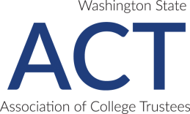
Transforming Lives
2020 Nomination Form

College:

Nominee’s Name:

The nominee is a Current | Former - Year Graduated
Washington community or technical college student.

Nominee’s contact information:
Address: Street
City, State Zip
Email:
Phone: (H): | (W): | (Cell):
Please provide a minimum of one phone number.

Requirements:

The nominee’s complete statement with a maximum of 600 words or less that includes responses to criteria questions.

A letter of support written by the board is included.

A head and shoulder photograph (300 DPI or higher) of the nominee is included.
Photographs should be limited to a plain, light background.

The college’s Transforming Lives liaison will work with the president or chancellor’s executive assistant (or designee) to register the college’s awardee and guest(s) for the awards dinner.

Nominee has been notified his or her statement and picture will be published in the Transforming Lives Booklet and the ACT website and shared with Legislators, CTC Stakeholders and the Public.

Will the nominee attend the 2/17/2020 dinner? The six awardees selected as keynote speakers are expected to attend.
Yes No Unknown

Nomination Deadline: November 8, 2019

The Washington State Association of College Trustees does not discriminate on the basis of race, color, national origin, religion, sex, disability, honorably-discharged veteran or military status, sexual orientation, or age in the administration of its programs and activities.

